Strategic Development Plan 2023 - 2027
STRATEGIC DEVELOPMENT PLAN 2023 - 2027


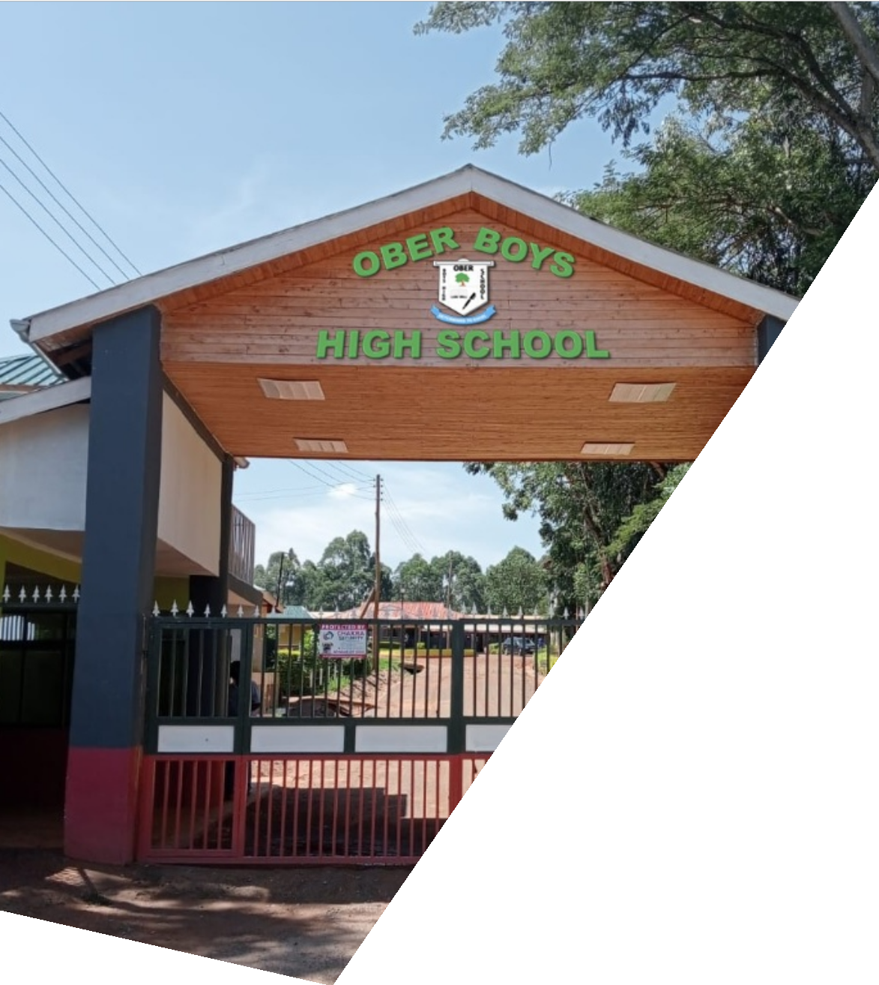
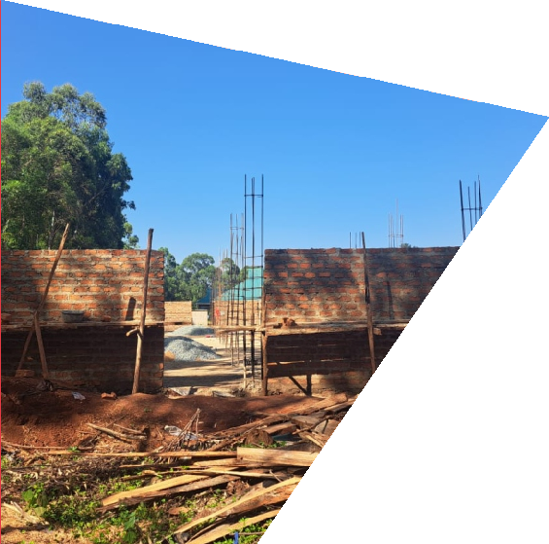
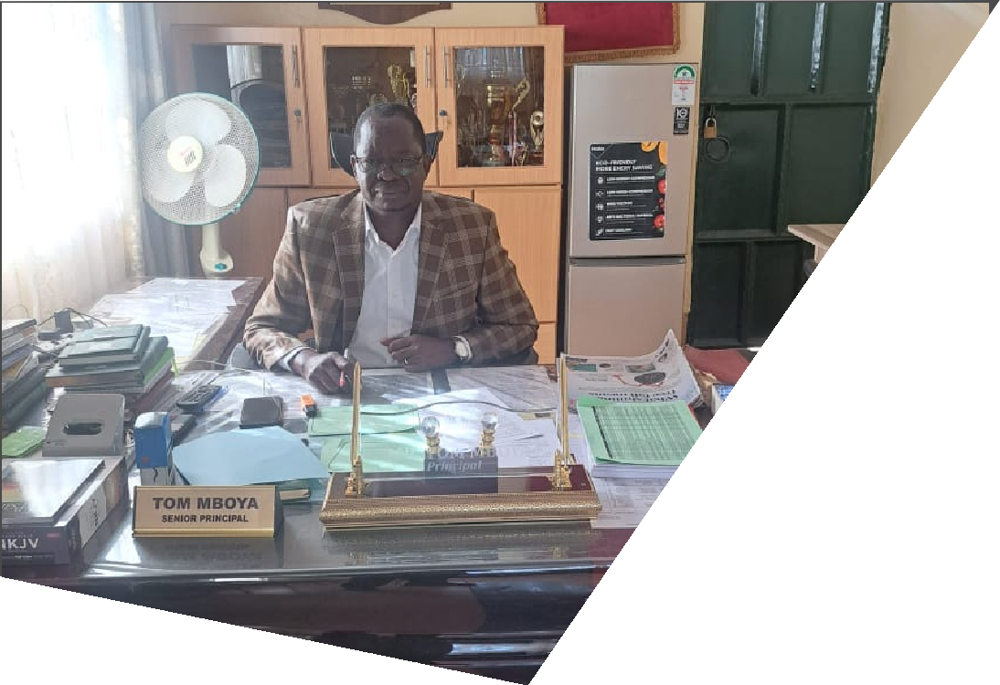
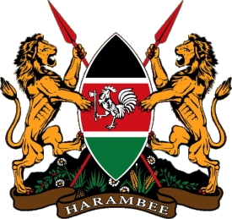
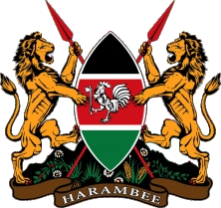
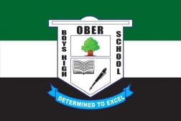
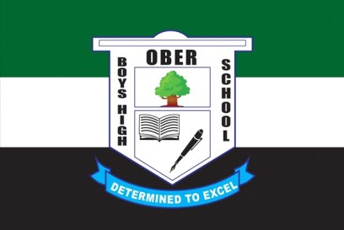
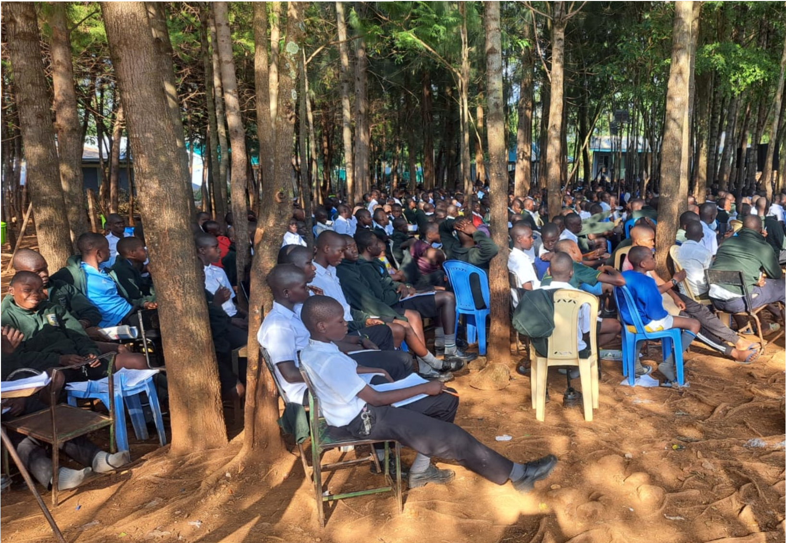

OBER BOYS’ HIGH SCHOOL

“Dermined to Excel”
P. O. BOX 318 – 40222, OYUGIS – KENYA
Email: obersecondary@yahoo.com

©Ober Boys' High School, 2023
STRATEGIC DEVELOPMENT PLAN 2023 - 2027
“Positioning for Excellence”

OBER BOYS’ HIGH SCHOOL
“Dermined to Excel”

©Ober Boys' High School, 2023

KEY STATEMENTS
MISSION
To provide, promote and coordinate the effective and efficient implementation of a Competency-Based Curriculum in the provision of equitable quality learner-centred education and holistic learner development while inculcating a culture of obedience, boldness, earnestness, responsibility, discipline, hard work, creativity, innovation, research and resilience for optimal learner performance in the post 21st Century Digital Age.
CORE VALUES
& PRINCIPLES
OUR MOTTO: “Determined to Excel”
ACADEMIC THEME 2023 – 2027: “Positioned for Excellence”
OBER BOYS HIGH SCHOOL STRATEGIC DEVELOPMENT PLAN (2023 – 2027) i | Page
2 Peter 1:5: “Now for this very reason also, applying all diligence, in your faith supplies moral excellence, and in your moral excellence, knowledge”.
Proverbs 8:14: “Counsel is mine and sound wisdom; I am understanding, power is mine”. The Book of Nehemiah 3: Plan and Involve People
STRATEGIC THEMES
Access and Equity; Quality and Relevance; Learner-Centered,Value- Oriented, Cost-Effective, and Open Governance and Accountability
VISION
To be a Center of Excellence in the Provision of Quality Inclusive Education and Holistic Learner Support for Sustainable Development

Table of Contents

KEY ST ATEMENTS LIST OF TABLES LIST OF FIGURES
DEFINITION OF KEY TERMS PREFACE
FORWARD
FORWARD BY TSC COUNTY DIRECTOR
FORWARD BY CHAIRMAN, BOARD OF MANAGEMENT ENDORSEMENT BY CHAIRPERSON, PARENTS ASSOCIATION
COMMITMENT OF THE SCHOOL PRINCIPAL&SECRETARY, BOARD OF MANAGEMENT ACKNOWLEDGEMENT
ABBREVIATIONS AND ACRONYMS

CHAPTER ONE
PAST FIVE -YEAR PLAN (2018 - 2022) PERFORMANCE OVERVIEW
- Introduction
  - Successes and Challenges During the 2018 – 2022 Strategic Plan Implementation
    - Successes:
    - Incomplete-Ongoing Strategic Development Projects and Actions
  - Challenges Experienced During the 2018 – 2022 Plan Implementation Period
  - School Admission and Enrollment During 2018 -2022 Plan Implementation Period
  - Kenya Certificate of Secondary Education (KCSE) Performance Trends during Plan Implementation Period (2018 - 2022).
  - Curriculum Based Establishment as at December 2022
    - Curriculum Based Establishment for Senior Master/Mistress as at December 2022
    - Gaps in the CBE
    - Short Term Interventions to address CBE Gaps
      - BOM Teachers
      - T eachers on Teaching Practice (TP)
      - TSC Intern Teachers

CHAPTER TWO
STRATEGIC STATEMENTS & STATEMENT OF INTENT
  - Purpose Statement
  - Vision Statement
  - Mission Statement
  - Overall Goal
  - Strategic Objectives
  - Specific Objectives
  - Projected Enrolment/Students’ Population (2023 – 2027)
  - Projected Academic Performance by Posted KCSE Mean Standard Scores (2023 – 2027)
  - Projected CBE by Employer (TSC/BOM) for the Period, 2023 – 2027
  - Justification of the School Strategic Plan (2023 – 2027)
i iv iv v vi vii ix x xi xii xiii xiv

- 1 -
- 1 -
- 1 -
- 1 -
- 1 -
- 2 -
- 2 -
- 4 -

- 5 -
- 6 -
- 7 -
- 10 -
- 10 -
- 10 -
- 11 -

- 12 -

- 13 -
- 13 -
- 13 -
- 13 -
- 13 -
- 13 -
- 13 -
- 14 -
- 15 -
- 16 -
- 16 -
- 17 -

OBER BOYS HIGH SCHOOL STRATEGIC DEVELOPMENT PLAN (2023 – 2027) ii | Page

Table of Contents

CHAPTER THREE - 18 -
LEGAL AND POLICY FRAMEWORK FOR STRATEGIC PLANNING - 18 -

3.1. Introduction | - 18 -
3.2. Kenya Education Sector Legal and Policy Framework | - 18 -
3.3. African Union’s Continental Education Strategy for Africa (CESA 16 -25) | - 19 -
3.4. The IGAD Education Policy Framework | - 20 -
3.5. United Nations Sustainable Development Goal No. 4: Quality Education | - 21 -
3.6. Implications of the Strategic Plan on Legal and Policy Environment | - 21 -
3.7. Conclusion | - 22 -

CHAPTER FOUR - 23 -
COORDINATION AND IMPLEMENTATION FRAMEWORK. - 23 -
  - Overview - 23 -
  - Strategy Implementation Approach - 23 -
  - Organizational Structure - 24 -
  - Optimal Staffing Levels and Human Resource Capacity - 25 -
  - Effective Performance Management System - 25 -
  - Creativity, Innovation and Prudent Management of Resources - 26 -
  - Staff and Students Motivation and Productivity - 26 -
  - Integration of ICT in Tea ching, Learning, Exam Administration and School Management - 28 -
  - Stakeholder Mapping, Analysis and Management - 28 -
  - Collaboration, Networking and Partnership Building - 32 -
  - Resource Mobilization and Fundraising by Potential Sources of Funds - 33 -
  - Institutional Sustainability - 33 -
    - Strategic Goal: - 34 -
      - Strategic Objective 1: Develop a School Culture and Tradition - 34 -

Strategic Objective No. 2: Achieve and sustain excellence in academic performance at all levels (Form I -IV), attaining MSS of at least 9.5 in subsequent KCSE Exams year - on

- 36 -

      - Strategic Objective No. 3: Improve, Expand and Maintain Adequate School Infrastructure for
Delivery of QualityEducation in a conducive and livable learning environment - 38 -
      - Strategic Objective No. 4: Achieving Excellence in Co -curricular activities including drama, - 40 -
games, sports and athletics
      - Strategic Objective No. 5: Achieving Excellent Environmental Quality and Contribution to
Climate Change Risks Mitigation . - 41 -
  - Grand Plan Implementation Budget by Strategic Objective Area - 41 -
  - Specific Infrastructure Development matric - 42 -
  - Success Factors in Plan Implementation - 45 -
  - Conclusion - 45 -

ANNEXES - 46-
- Forwarding Letter by the County Director of Education - 46 -
- Certified Copy of School Registration Certificate - 46 -
- Certified Copy of School Land Title Deed - 46 -
- Minutes of the Board of Management Adopting and Approving the Strategic Plan for Implementation - 46 -
- Project Proposal for High Priority Turn-Key Development Projects presented to the Ministry
of Education through the CDE, Homa Bay County. - 46 -
- Certified Copy of School Physical Development Site Plan - 47 -
- Certified Copies of Major Infrastructural Development Plans with Bills of Quantities - 47 -

OBER BOYS HIGH SCHOOL STRATEGIC DEVELOPMENT PLAN (2023 – 2027) iii | Page

List of Tables
OBER BOYS HIGH SCHOOL STRATEGIC DEVELOPMENT PLAN (2023 – 2027)
iv | Page

Table 1: | Fees arrears as at 31st December 2022. | - 3 -
Table 2: | School Admission and Enrollment During 2018-2022 Plan Implementation Period | - 4 -
Table 3: | KCSE Performance Trends during Plan Implementation Period (2018 – 2022) | - 5 -
Table 4: | No. of Students by KCSE Mean Grade between 2018 - 2022 | - 6 -
Table 5: | Deputy Principals and Senior Masters of Secondary Schools as per CBE. | - 7 -
Table 6: | Curriculum Based Establishment for Senior Master/Mistress as at December 2022 | - 8 -
Table 7:  Table 8: | CBE per Department by No. of Staff be Department (Current and Projected) Teachers on TP received by the school per year by their origins (names of  universities/colleges) | - 9 -  - 10 -
Table 9 | Actual and Projected TSC Intern Teachers by Year | - 11 -
Table 10:  Table 11: | Project Enrolment vs Classes Expansion Needs between 2023 - 2027  Actual vs Projected MSS, Total Candidates Enrolled and % Transition to Varsities  per annum | - 14 -  - 15 -
Table 12: | TSC Approved CBE Establishment for Secondary Schools in Kenya. | - 16 -
Table 13: | Stakeholder Mapping, Role Specification and Relevance in Plan Implementation | - 28 -
Table 14: | School Culture and Tradition Development Matrix | - 34 -
Table 15: | Logical Framework for Academic Result Improvement | - 35 -
Table 16: | Logical Framework for School Infrastructure Development | - 37 -
Table 17: | Logical Framework for Co-Curricular Activities | - 39 -
Table 18: | Logical Framework for Climate Change Adaptation & Mitigation | - 40 -
Table 19: | Grand Plan Implementation Budget | - 40 -
Table 20: | Infrastructure Implementation Matrix | - 41 -
Table 21: | Academic Standards Improvement Matrix | - 42 -

List of Figures
OBER BOYS HIGH SCHOOL STRATEGIC DEVELOPMENT PLAN (2023 – 2027)
v | Page

Figure 1: August 2022, Mt. Kenya Dormitory Razed | - 3 -
Figure 2: Organizational Structure | - 24 -
Figure 3: School Physical Site Plan | - 47 -

Definition of Key Terms

 | TERMINOLOGY |  | OPERATIONAL DEFINITION
 | Basic Education |  | Education that covers pre -primary, primary, secondar y, adult and continuing education, non -formal education institutions offering the national curriculum (also acronym as APBET) and teacher training colleges but excludes technical and vocational education and training programmes.
 | Cabinet Secretary |  | This means the Cabinet Secretary for the time being responsible for matters relating to Basic education and training
 | Candidate |  | This means a person enrolled by the Kenya National Examination Council (KNEC)to sit for one of the KNEC’s examinations as prescribed by the KNEC Act Cap. 225A
 | Child Class |  | means an individual who has not attained the age of eighteen years Refers to a group of learners at a particular level of education e.g., Junior  Secondary Grade 7, Grade Eight; Senior Secondary Grade 9, Grade 10, Grade 11 and Grade 12 etc.
 | Community County Director of Education |  | This means persons residing in the neighborhood of Ober Boys’ High School This means a Director appointed under section 52
 | County Education Board |  | An Agency of the Ministry of Education created by section 17 of the Basic Education Act No. 14 of 2013 to carry out the delegated function of managing basic education and training at the county level on behalf of the Cabinet Secretary
 | Curriculum |  | This means all the approved subjects taught or programmes offered and includes all the activities provided by Ober Boys’ High School within the framework of the National Curriculum of Education in Kenya
 | Learner Friendly |  | Applies to the state of conduciveness and livability of learning and teaching environment with friendly and supportive staff, where the rights of learners are upheld and their health and safety needs are catered for.
 | Parent’s Association Principal” |  | This means an association as prescribed in subsection 53(2) of the Act Has the meaning assigned to it under the Teachers Service Commission Act Cap 212 (1968), Revised Edition, 2009, Laws of Kenya
 | Stream The Act |  | Refers to the number of classes at a particular grade  This means Basic Education Act No. 14 of 2013, Laws of Kenya

OBER BOYS HIGH SCHOOL STRATEGIC DEVELOPMENT PLAN (2023 – 2027) vi | Page

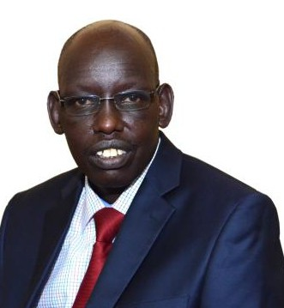
PREFACE

The Government of Kenya, through the Ministry of Education Science and Technology, has remained persistently and visibly committed in the implementation of national education policy shifts occasioned by the promulgation of the Constitution of Kenya, 2010. The investments so far made in the education sector has seen Kenya emerge the fifth after Mauritius, South Africa, Morocco and Botswana in the 2022 index done by the World Intellectual Property Organization (WIPO). Despite dropping three points from the 2021 ranking, Kenya still emerged 88th globally after investments made in education were viewed as a key strength for the country with a potential for driving global education goals and contributing effectively towards the realization of the UN SDG #4 in Kenya by the year 2030.

Efforts by the Government has seen Kenya realize rapid infrastructure
development in all public primary and secondary schools not excluding institutions of higher learning. The Government has also remained committed to ensuring a very smooth and seamless transition from the 8.4.4 to the 2-6-3-3-3 system of education, herein also referred to as the “Competency-Based Education” Curriculum. The Government seeks a wider education sector stakeholder participation and involvement in the process of making our education sector more robust, industry and labour market oriented and with appropriate and adequate human, technical and financial muscle to ensure a well-developed education system with enrolment and transition rates in both primary and secondary school maintained at 100 per cent.

In view of the commitment by the Government to implement in letter and spirit the provisions of Article 53 (1)
(b) that state that every child has a right to free and compulsory basic education and Article 55 (a) that compels the State to take measures, including affirmative action programmes, to ensure that the youth access relevant education and training. The Basic Education Act (2013) guarantees the right of every child to free and compulsory basic education. The government is also committed to implementing international and regional commitments related to education, such as the Education for All (EFA) goals and Sustainable Development Goals (SDGs), among others.

The step taken by the Board of Management, Staff, Parents and Students of Ober Boys High School in formulating this Strategic Plan (2023 – 2027) is quite inspiring not only to the Ministry of Education, but to entire Education Sector fraternity. The Strategic Plan has characteristics including: (a) Strong legal and policy framework orientation; (b) Futuristic; (c) Relevance to national goals and objectives of education in Kenya; (d) learner- centered and (e) Responsive to current and emerging needs of the school. The school's focus on matching infrastructure development and expansion to increase of students' gross enrollment rate while keeping pace with recommended Curriculum Based Establishment guidelines by theTSC is quite commendable.

Going forward, the Ministry of Education will continue to support the school in the implementation of the new strategic plan (2023 – 2027) as it did with the just concluded strategic plan (2018 – 2022). Focus of the Ministry of Education will be to work with school stakeholders in the implementation of the Government of Kenya's Education Sector Policies, Programs and Priorities, and in this footing, I find this strategic development plan quite appropriate for driving our common goals and objectives in education in the best interest of the Kenyan children.

………………………………………..
DR. BELIO KIPSANG,PhD
Principal Secretary, State Department of Early Learning and Basic Education

OBER BOYS HIGH SCHOOL STRATEGIC DEVELOPMENT PLAN (2023 – 2027) vii | Page

FORWARD

It is indeed a great honor and pleasure to present to the Ministry of Education and the Education Sector fraternity the Ober Boys' High School's Second Strategic Development Plan (2023- 2027).The Strategic Development Plan (2023 – 2027) succeeds the first ever Institution's Strategic Development Plan (2018 - 2022). The development of this Strategic Plan took into account several success factors that drives quest for excellence in school management, operations and outcomes realization.The drafting process considered the successes and challenges recorded from the implementation of the first Strategic Development Plan (2018 – 2022) while noting and emphasizing of lessons learnt, achievements, challenges, opportunities and recommendations of various stakeholders.

In addition, the design and development of the OBHS's Strategic Development Plan (2023 – 2027) was accurately guided by the strategies outlined in Sessional Paper No. 1 of 2019;The National Education Sub-Sector Plan (NESSP, 2018-2022), and the Kenya Vision 2030 3rd Medium Term Plan (2018-2022) while keenly adopting various sector policies, guidelines and plans as issued by MoE from time to time, especially with regards to the transition to a new curriculum model in Kenya, 2.6.3.3.3. The deep and thoughtful alignment of this Strategic Development Plan with National, Regional, Continental and Global Education Sector Policies and calls to actions further makes this strategic plan a model plan that will not only impact development progress and learning outcomes at OBHS, but will provide a vital reference tool for several other Extra-County Schools in Kenya seeking to curve a niche in Excellence ethos.

This Plan has coined a new set of value propositions founded and premised on the name of the school, OBER.This has clearly shown the high level of commitment to promote Plan ownership all its primary stakeholders including the students, staff, parents/guardians and immediate community members that directly associate with the name,“OBER”. Obedient, Brave, Earnest and Responsible children is a recipe for a prosperous and ingenuous generation that Kenya desperately needs to capture opportunities availed by the emergence of the digital and innovative global economy while addressing some of the global challenges such as climate change, global economic crunch, shrinking national economies, emergence of life-threatening diseases and pestilence among others. The commitment by the school Board of Management and the school principal in ensuring that the strategic goal, objectives and development outputs of this plan is realized is quite re-assuring and captivating.

The strategies espoused for improving and sustaining high and enviable academic performance and standards at OBHS is quite in line with the Government of Kenya's National Policy aspirations. The Government is quite keen on development of Science Technology Engineering and Mathematics (STEM) without compromising other subjects and aspects of child growth and development.The Education Sector Policies views STEM as driving force in the pursuit of Kenya's Vision 2030 through the implementation of Education Sector's Medium Term Expenditure Framework 2023/24 – 2025/26 that envisions attaining “Quality and inclusive education, training and research for sustainable development” in Kenya. The Sector's strategic objectives are to: enhance access, equity, quality and relevance in education, training and research; establish, maintain and manage professional teaching and learning services for all early learning centers, primary, secondary and tertiary institutions; enhance development capacities for Science Technology and Innovations; improve data quality and sharing in education, training, research and labor market; promote vibrant industry-institutional linkages in the area of skilling for employability; and integrate ICT in Education, Training and Research for management, teaching and learning at all levels.All these sectoral policy imperatives have been quite well captured in this Strategic Development Plan.

It is on above background that I so highly recommend and forward this Plan to the Ministry of Education Science and Technology as well as Sector stakeholders for support towards its full-scale implementation.

EUNICE KHAEMBA,MRS
County Director of Education Homa Bay County

OBER BOYS HIGH SCHOOL STRATEGIC DEVELOPMENT PLAN (2023 – 2027) viii | Page

FORWARD


The TSC County Directors are stationed in each of the 47 counties in Kenya with a delegated office answerable to the TSC Regional Coordinators for among other responsibilities to identify staffing gaps in schools within the county; Coordinate teacher recruitment at the county and ensure that the Commission's recruitment guidelines in force are adhered to; Maintain a data base of registered teachers including the unemployed teachers within the county; Manage aspects of teacher management as per the existing policy and guidelines within the county through: – (i) Recruitment; (ii) Transfers; (iii) Posting; (iv) Receiving and recommending teachers' study leave; (v) Handling disciplinary matters as directed by the Commission Secretary; and (vii) Identifying through a competitive process and recommending to the Commission Secretary, teachers to be deployed to administrative positions.
The TSC County Directors are also responsible to the Commission Secretary for the implementation of guidelines issued by the Commission from time to time; Maintain a data base for all administrative posts in the county; Maintaining a data bank of all teacher vacancies available at the county; Coordination of identification and selection of candidates for Teacher Professional Development Courses (TPDC) within the county as per the guidelines issued by the Commission from time to time; Coordination of teacher promotions under the common cadre establishment within the county; Ensuring that teachers comply with the teaching standards prescribed by the Commission; Monitor the conduct and performance of teachers at the county level; Oversee performance appraisal of teachers at the county level; Submit other reports related to performance of teachers as the Commission may require from time to time;Transmit reports from heads of institutions to the Commission; Supervise staff within the county; Advise the respective county governments on matters relating to the teaching profession; Establish mechanisms to enhance communication and service delivery at the county; Liaise with the Commission Secretary and other stakeholders in resource mobilization.
The preparation and subsequent publication of the Second Strategic Development Plan (2023 – 2027) for Ober Boys' High School reflects the high level of comprehension of the Teacher and Teaching Process Management at the School- level by the Board of Management, Staff and other stakeholders of the school.The quality of teacher management related data reported and or forecasted in the Strategic Development Plan presents to the commission a clear needs assessment for teachers and teacher professional development that will go a long way in guiding the Commission Secretary in making technical and professional staffing needs andTPD services at OBHS.
As an office of the Commission at the County level, the Plan presents an opportune tool for effective teacher management and teacher professional development that will definitely guide the Commission on its quest to implement institutional capacity building and organizational strengthening in Kenya, with OBHS being one of the model schools to show-case the Commission's commitment with regards to its mundane task assigned to it by Article 237(2) of the Constitution of the Kenya, 2010.
The Commission looks forward to supporting OBHS to achieve its optimal CBE for effective teaching and learning service delivery during the Plan Implementation Period (2023 – 2027).

…………………………….. DR. Esther Musanii, PhD
TSC County Director, Homa Bay

OBER BOYS HIGH SCHOOL STRATEGIC DEVELOPMENT PLAN (2023 – 2027) ix | Page

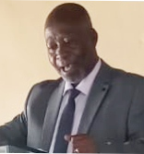
FORWARD

Ober Boys' High School was founded 75 years ago as a mixed primary school, then known as Bware Local Native Council (LNC). In 1959 it became Bware DEB and later same year, it become an Intermediate school with an upper primary school. In the same year, the name of the school changed to OBER DEB. In 1977, the Secondary School was started as a mixed school with Mr Philip Owili as the pioneer Principal.The land where the school sits was donated by local families of Gonya, Salmon Oyieko, Oyengwe (Nyambega), Kanyango (Angote), Otondo and Kirongo. Its total land size is 6.8 hectares.The school has continued to grow in lips and bounds since 1977 with Mr Benjamin Randa as the Board Chair, recording impressive growth in its enrolment rates, infrastructure expansion and development and academic performance.
I am privileged to be the 6th Chair of the Board of Management, serving my second term and very proud to be part of this great community as we celebrate
our 46th school birthday and the launch of our second strategic development plan under my leadership. I am humbled too that this development roadmap for our school comes at the start of mysecond as the Chairman, Board of Management.This challenges me to use this window period of service to the school to carve out my own legacy to be indelibly etched in the footprints of this great school in Rachuonyo East Subcounty in Homa Bay County, just like predecessors did during their time as leaders in this school.
I view the progresses so far made as a result of collectiveness and team spirit that has lived on in the school since its inception. The ability of the school's stakeholders to see the vision and be guided by school mission statements in decision making process humbles my spirit a lot.The willingness of our staff and students to pay a price to maintain a culture and tradition of excellence in all facets of education and child's holistic development, and to realize and maintain the good image and brand of the school is a secret that ought to be guarded so jealously moving forward.
As we roll-out the second strategic development plan for our school, I am confident that the momentum of growth and development already realized will not only be maintained, but shall be scaled up even as we open our doors and gates to wider collaborations, partnership and networking with both local and international development partners and funding agencies.This approach is envisaged to be a sure way of resourcing the effective and impactful implementation of the Strategic Development Plan, hence achieving its desired targets in time, within the constraints of resources and institutional capacity at the present time.
As a Board, we commit to this Plan by borrowing from the Book of Nehemiah 3.As Nehemiah, the Board recognizes the centrality of the people (specific individuals, entities and organizations) in the success of this Plan.We borrow heavily the Godly principles in the Book of Nehemiah 3 and Romans 12 that implores upon us, first to “PRAY”.Then “PLAN”.After PLANNING, seek “RELEVANT PERMISSIONS AND APPROVALS” from relevant authorities as by law required. Once permissions and approvals are granted, then we are called upon to “MOBILIZE RESOURCES” needed in order to effectively implement this Plan. Once resources are availed, it is our honorable duty and obligation to work to standard, prudently utilizing and managing available resources, monitoring and evaluating progress and giving reports to our stakeholders and financing agencies. It is through these Nehemiah's principles and strategies that this Plan has been designed and developed to enable us to build a greater and prosperous OBER BOYS' HIGH SCHOOL with the help of God the Almighty.
As per the readings of the guiding scriptures, we shall apply all diligence relying fully on the Lord's promises even as we conscientiously supply and inculcate moral excellence in our learners through the application of sound and wise Godly counsel and wisdom. In this, we are definitely positioned for excellence!
My prayers!
…………………………………………….. Rev. Bishop Daniel Ochieng
Chairman – Board of Management (2023 – 2027)
OBER BOYS HIGH SCHOOL STRATEGIC DEVELOPMENT PLAN (2023 – 2027) x | Page

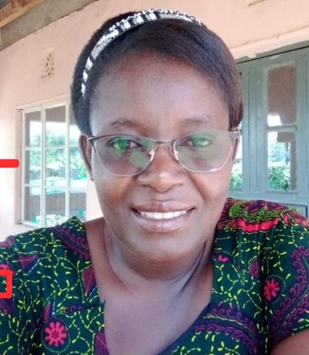
PARENTS ENDORSEMENT

The desire of each and every parent is to see his or her child grow in an environment that positively impact life, now and into the unforeseeable future, developing critical life skills and competencies that positions the child into the high levels pedestal that propels the child to success and even more success in life. The only known social-economic equalizer that can build a child from humble background to higher grounds of prosperity in all spheres of life is “QUALITY EDUCATION”. Education that focuses on the whole person, not just a segment thereof.

As an Association of parents of Ober Boys' High School, we find this Strategic Development Plan quite tailored to the needs of our children – academic, social, spiritual, leadership, life-skills development and above all the holistic development of the child. The plan seeks to implement strategies that will enhance teacher-student contact hours, classroom instruction, learning outcomes, elevate and motivate students' involvement in the teaching and
learning processes and productivity realization, and effectively manage and mold students' character, behavior and conducts.

The core values espoused in the Strategic Plan's Key Statements, that is Obedient Children that are Bold, Earnest and Increasingly Responsible responds effectively to the national aspirations of a successful education system, capable of developing solidly patriotic citizens that are characterized by their ability to:
- Obeys the law and respect authority;
- Contribute positively to the Society and Community by performing their Civic Duties in a manner that contributes significantly to national development;
- Loves his/her community and country and lives by the dictates of our national philosophy as embodied in the words of our National Anthem and the Flag of our Republic;
- Practices courtesy and respect for the rights of others.
- Be trustworthy and honest.
- Be tolerant.
- Be accountability and transparent,
- Continuously and increasingly conserving and protecting nature and environment.
- Resist corruption and abuse of office
- Command high moral courage.

It is my firm belief that as parents, this Plan is a gift in time and that its successful implementation shall be our joy, now and into the future. I therefore call upon all parents/guardians/sponsors and the alumni association to stand with the Board of Management as they put into practice the provisions of this Plan.

Together we win.

MADAM MARY OCHIENG PA CHAIR (2023 – 2026)

OBER BOYS HIGH SCHOOL STRATEGIC DEVELOPMENT PLAN (2023 – 2027) xi | Page


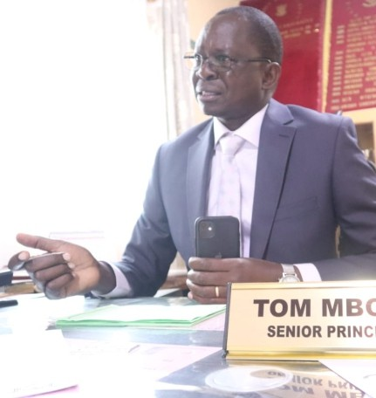
COMMITMENT OF THE SCHOOL PRINCIPAL & SECRETARY, BOARD OF MANAGEMENT
Guided by TSC/QAS/PC-PSS/2023 (performance contract between the Teachers Service Commission and the Principal of Ober Boys' High School, January 2023 to December 2023) and guided by the commitment of the principal to the Board of Management where he serves as secretary, I commit to:
- To provide the required leadership in designing suitable plans and strategies to deliver educational services and enable this school to realize its goals. I will also perform my duties and responsibilities diligently and to the best of my ability to support the achievement of the agreed performance targets;
- In carrying out my duties, especially as guided by the strategic goal and specific objectives of the School Strategic Development Plan (2023 – 2027), I intend to put all my efforts towards contributing effectively and efficiently to the achievement of the national development agenda as espoused in the Kenya Vision 2030 and to contribute to the realization of the National
Education Goals, keeping in mind the specific priorities of this school as captured and articulated in this Strategic Development Plan.
- Bearing in mind the imperative of quality and inclusivity, I commit to work with all education stakeholders in implementing the key development projects, education service delivery strategies and institutional capacity development for effective and efficient supervision, teaching, learning and learner assessment, while promoting upward career progression of all staff working with me to realization the vision, mission and objectives of the school.
- This committal statement reiterates the need to put down the specific strategic objectives to be achieved during the contract period, and into the foreseen future of the school, hence the school's commitment to deliver the objectives and intents of this School Strategic Development Plan (2023 – 2027).
- I commit therefore to ensure FINANCIAL STEWARDSHIP ANDDISCIPLINE and Improve service delivery standards for the learners by among other core mandates:
  - Maintenance of the teaching standards in the implementation of curriculum (performing the role of quality assurance within the institution).
  - Ensure effective, effective and participatory Institutional Administration (as the lead educator and administrator at the school).
  - Ensure timely updated database on learners' enrollment, Curriculum Based Establishment for teaching staff and non-teaching staff, as well as maintain accurate school's assets register and inventories.
  - PromoteTeacher Professional Development (TPD) programs at the institutional level.
  - Submission ofTermly and Annual Reports toTSC, MoE and project/s funding partners – local and international.
  - Cultivating, nurturing and sustaining cordial and mutually inclusive and beneficial working relationship with all school and education stakeholders in the very BEST INTEREST of the learners/children of Ober Boys' High School, Rachuonyo East Sub-County in Homa Bay County, Kenya.

MR.TOM ODHIAMBO MBOYA
SENIOR PRINCIPAL, OBER BOYS' HIGH SCHOOL

OBER BOYS HIGH SCHOOL STRATEGIC DEVELOPMENT PLAN (2023 – 2027) xii | Page

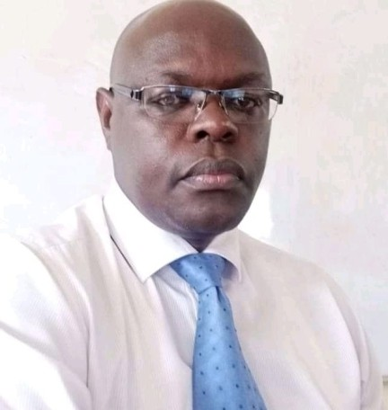
ACKNOWLEDGEMENT

First and foremost, The Board of Management (BOM), the Parents' Association (PA), Students, Staff and the entire Ober High School family is extremely grateful to the Almighty God, the author and finisher of knowledge, wisdom and understanding, for His countless mercies, love, grace and kindness that have enabled us to complete our previous Strategic Plan Implementation phase of 2017 – 2022, and to craft and complete yet another new School Development Strategic Plan (2023 – 2027).What a wonderful God we serve!

Secondly, special thanks go to our Board Chairman, Rev. Daniel Ochieng for his great spiritual, emotional and elderly guidance to the BOM and support he accorded the Strategic Planning Process.We acknowledge his meek and humble leadership style that has remained unto us the source of
our deep inspiration to always look upon God to guide each of our steps in the journey to Excellence.

Thirdly, we are grateful to the respective Standing Committees of the School Board of Management for their sterling oversight, policy guidance and motivational roles they played during the previous Strategic Plan implementation phase and their evident commitment to the current Strategic Plan and its aspiration.

Fourthly, we recognize and appreciate in a very special way our Subcounty Director of Education, Mr. David Gekara for always being closure to ensure that the school got the best of technical and professional backstopping in so far as compliance to policy, rules and regulations by the Ministry of Education is concerned. We are equally thankful to Mr Gekara for his valuable inputs during the plan formulation and development processes.

Fifthly, our sincere appreciation to the Management Staff of Ober Boys High School led by Mwalimu Tom Odhiambo Mboya and Mwalimu Benard Sijenyi.Your support and dedication to Quality and Results-based Management System is the impetus that thrived and sustained the process of developing this strategic development plan. Keep it up!

Sixthly, the BOM is highly grateful to Mr. Richard Ochieng Bonyo, PhD Candidate at the University of Nairobi, School of Business and Management Sciences, and a member of the BOM's SIC who volunteered his immense wealth of knowledge and expertise in Project Planning and Management in order to help craft and develop this quite comprehensive, succinct and pragmatic Strategic Development Plan. Mr Bonyo is aptly recognized for translating the school vision and mission statements into specific goals and objectives in a manner that is now easy to contemplate and relate with our development realities as a school.

We are profoundly thankful to each member of the BoM, PA, teaching and non-teaching staff, students and parents of Ober Boys High school for their unwavering support to the school and it is our sincere hope and prayer that this valued support will continue into the unforeseen future.

Finally, Special thanks to Mr Billy Agwanda, School Bursar for his valuable support towards accessing up-to date school financial data and reports.

……………………………….. Mr. Benard Sijenyi Deputy Principal,Administration

OBER BOYS HIGH SCHOOL STRATEGIC DEVELOPMENT PLAN (2023 – 2027) xiii | Page

List of Acronyms
AGR Agriculture
BIO Biology
BOM Board of Management
CBC Competency Based Curriculum CBE Curriculum Based Establishment CDE County Director of Education CHE Chemistry
CUEA Catholic University of Eastern Africa
EFA Education for All
ENG English
GEO Geography
GIZ Deutsche Gesellschaft für Internationale Zusammenarbei
ICT Information Communication Technology KCSE Kenya Certificate of Secondary Education KEMU Kenya Methodist University
KENHA Kenya National Highways Authority
KES Kenya Shillings
KICD Kenya Institute of Curriculum Development
KIS Kiswahili
KNEC The Kenya National Examinations Council
KU Kenyatta University
LIT Literature
LNC Local Native Council
MAT Mathematics
MDAC'S Ministries, Departments, Agencies and County Governments
MEAL Monitoring Evaluation and Learning
MKU Mount Kenya University
MoE Ministry of Education
MSS Mean Standard Score
Mt. Mountain
MUST Meru University of Science and Technology
NG-CDF National Government Constituency Development Fund
OBHS Ober Boys' High School
PA Parents Association
PC Performance Contract
PhD Doctor of Philosophy
PHY Physics
PSC Public Service Commission QAS Quality Assurance and Standards REV. Reverend
RU Rongo University
SCDE Sub-County Director of Education SDGs Sustainable Development Goals SEKU South Eastern Kenya University
STEM Science Technology Engineering and Mathematics
TMU Tom Mboya University
TP Teaching Practice
T-PAD Teacher Professional Appraisal and Development
TPD Teacher Professional Development TSC Teachers Service Commission UN United Nations
UoN University of Nairobi
WIPO World Intellectual Property Organization

OBER BOYS HIGH SCHOOL STRATEGIC DEVELOPMENT PLAN (2023 – 2027) xiv | Page


CHAPTER ONE

PAST FIVE-YEAR PLAN (2018 – 2022) PERFORMANCE OVERVIEW
    - Introduction
This Strategic Development Plan (2023 – 2027) is a successor of the 2018 – 2022 strategic plan. The 2018 – 2022 Strategic Pan focused on institutionalizing planning, resource mobilization and resource utilization in the quest to match development and priority needs in the background of scarcity of resources. During the 2018 – 2022 Planning Period, the Board of Management (BOM) and the school stakeholders focused on academic excellence, co-curricular activities, infrastructure development, addressing emerging issues such as compliance with health, security and safety standards and regulations as well as mainstreaming of resource mobilization and fundraising into the School Development Strategies.

      - Successes and Challenges During the 2018 – 2022 Strategic Plan Implementation
In the planning period 2023 – 2027, the Board of Management has taken stock of the successes
and challenges realized during the implementation of the 2018 – 2022 Strategic Plan including but not limited to:
        - Successes:
The five (5) year strategic plan that has been in operation since 2018 achieved over 90% of its targeted areas for infrastructure investment and development, academic standards improvements and attainment of best outputs as envisaged in the Plan Implementation Matrix. Chief among these achievements include the following:-
- Expansion of learning and boarding facilities including construction of 12 new classrooms and 3 departmental offices all housed in the newly built tuition block;
- Increased enrolment from 936 students in 2018 to the current 1,963 students (Form I: 603; Form II: 607; Form III: 454; and Form IV: 299 students)
- Increased number of streams from 4 per class in 2018 to between 5 and 8 streams in 2022 (Form I: Eight (8) Streams; Form II: Eight (8) Streams; Form III: Seven (7) Streams; and Form IV: Five (5) Streams respectively).
- Installation of 1no by 3-phase power generator;
- Construction of 2nos modern hostels (Mt. Everest and Mt. Carmel);
- Improvement of school Mean Standard Scores from 4.9 in 2016 to 8.6 in 2022;
- Chain fencing of the entire school compound and installation of a Gate with Gate House;
- Complementing of local security guards with professional guards for contracted security firm;
- Installation of CCTV Cameras in all key strategic areas to boost security surveillance on a 24/7 basis;
- Installation of high voltage security flood lights in the entire school compound to boost security surveillance at night;
- De-grilling windows and changing all doors to open outwards to further enhance safety and security preparedness in the school in-case of emergencies; and
- Installation of Fire-Extinguishers at Strategic Locations across the school as well as safe fire assembly points;
- Introduction of instant positive and negative rewards mechanism that are intended to boost and sustain the School's Academic Standards while enabling the students to live and lead the CoreValues of the School coined from the School Principal Name, “Obedience Brave Earnest Responsible” children.

OBER BOYS HIGH SCHOOL STRATEGIC DEVELOPMENT PLAN (2023 – 2027) 01 | Page

- Expanded the School Dining Hall. However, it is currently used as a temporary hostel for Form 1 students.
- Converted the wood-based school jikos into clean and renewable energy cooking gas jikos
- Tarmacking of the main entrance path courtesy of Corporate Social Responsibility of KENHA

        - Incomplete-Ongoing Strategic Development Projects and Actions
During the Strategic Plan Implementation, the following planned projects/activities were not implemented / completed:
- Attainment of a minimum MSS of 6.0 in Mathematics, 8.0 in Biology, 10.0 in Physics, 7.5 in Chemistry, and 9.0 in English
- Construction of 20 staff house (Single Bed-rooms)
- Acquisition of a school van and additional school bus
- Construction of multiple-story hostel with a capacity for up to 900 students (450 students per hostel)
- Attainment of optimal Curriculum Base Establishment of 63TSC EmployedTeachers. Currently, the school has only 22TSCTeachers and 41 BOMTeachers.
- Construction of additional 8 rooms science laboratories (2 rooms per science subject)
- Construction of 500-Student Sitting Capacity School Library
- Construction of 40 – doors students' toilets
- Conversion of the current school administration block into a modern and spacious Administration Block with a Board Room, Radio Communications Room, a Store and Conference Hall.
- Introduction of Solar Lighting System to provide a reliable, cost effective and easy maintenance energy supply solutions in the entire school compound
- Construct, equip and furnish food store, tools and appliances store and school garage.
- Acquire 17-seater Coaster Shuttle and a School pick-up vans
- Digitalization ofTeaching and Learning Processes through increased use of digital teaching and learning aids and resources

      - Challenges Experienced During the 2018 – 2022 Plan Implementation Period During Strategic Plan Implementation period (2018 – 2022), the school underwent the following drawbacks that curtailed full-scale realization of Plan targets:-
Emergence of COVID – 19 in the Year 2019/2020: The year 2020 began creditably with a lot of expectations for the school.Teachers and learners had sharpened their academic tools to begin the year and pursue set targets. January and February 2020 started well. However, on 31/05/2020, the school unanticipatedly grasped the sad news that Chief Principal, Mr. MauriceW. Muholo had succumbed to Covid-19.This led to throwing into disarray learning programmes in the school owing to stigma that was then associated with COVID-19. Fear gripped the entire school community.The closure of institutions by the Government on

OBER BOYS HIGH SCHOOL STRATEGIC DEVELOPMENT PLAN (2023 – 2027) 02 | Page

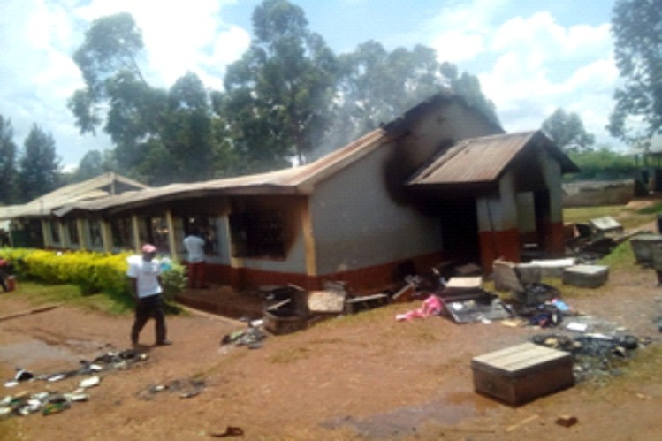
- March 15, 2020, further affected learners and teachers emotional, spiritual, psychological and general well-being and academic preparedness. Additionally, it also sired quite a few challenges on economic and social issues including interrupted and loss of learning, financial constraints on households, homelessness, poor childcare and sexual exploitation especially to the underprivileged in the urban centers. Stress levels increased leading to unruly behaviors in certain cliques of students.
- Increased Stress Levels in Students: Challenges occasioned by the emergence of
COVID-19 such as loss of loved ones, loss of incomes and sources of livelihoods, separation and weakening of family ties destabilized to a great extent the families and communities.This has been manifested in the reduced capacities to pay school fees and meet other learning obligations by most students. Other related challenges associated with this experience has been a change in behavior among some boys. For instance, in August 2022, a group of 11 boys, who were later found to be undergoing different levels of stress and had consequently indulged in drugs and substance abuse, razed the Mt. Kenya Dormitory at dawn leaving all occupants without any of their personal effects, thereby hampering KCSE Exams preparedness among the affected students.

Figure 1: August 2022, Mt. Kenya Dormitory Razed

- Poor Fees Payment Trends: Owing to challenges emanating from the adverse impacts of COVID-19, ensuing national and international economic recession, skyrocketing cost of living affecting prices of basic commodities, many parents and households have literally been rendered helpless when it comes to meeting their obligations, especially regarding school fees payment.As at December 2022, the school fees balance by class were as per the table below:

Table 1: FEES ARREARS AS AT 31ST DECEMBER 2022.

 | Form | Total | %Age
One |  | 1,493,803.00 | 22
Two |  | 1,709,369.00 | 26
Three |  | 1,823,880.00 | 27
Four |  | 1,669,810.00 | 25
Total |  | 6,696,822.00
Source: School data, 2022

OBER BOYS HIGH SCHOOL STRATEGIC DEVELOPMENT PLAN (2023 – 2027) 03 | Page

- Political Goodwill: During the period 2018 – 2022, and immediately preceding period, the school had a frosty relationship with the Office of the Area Member of Parliament, an experience that saw the school get little to no tangible support from the National Government Constituency Development Fund (NG-CDF).This has since changed as the school BOM adopts a non-political, non-religious and non-sectarian relationship policy in the best interest of the child and in conformity to the National Principles andValues under the Constitution of Kenya 2010.
1.1. School Admission and Enrollment During 2018-2022 Plan Implementation Period The following table presents the summary overview of school admission and enrollment trends by class/stream during the Plan Implementation Period (2018 – 2022): -

 | NO. CLASS STREAM CLASS TEACHER (TSC/BOM) 2018 2019 |  |  |  |  |  | 2020 | 2021 | 2022
 | 001 | Form 1 | Achievers | JUDITH AWACHA (TSC) | 52 | 55 | 64 | 67 |  | 75
 | 001 | Form 1 | Conquers | BENJAMIN KALAMA (BOM) | 51 | 53 | 64 | 62 |  | 75
 | 001 | Form 1 | Heroes | JOYNA OWINO (TSC) | 51 | 56 | 65 | 63 |  | 76
 | 001 | Form 1 | Giants | ALFRED OKETCH (BOM) | - | - | - | - |  | 75
 | 001 | Form 1 | Leaders | STEVE AUSTINE (BOM) | - | - | - | - |  | 76
 | 001 | Form 1 | Kings | PHELIX AJIMO (TSC) | - |  | - | - |  | 75
 | 001 | Form 1 | Victors | LAWRENCE OTIENO(BOM) | - | - | 65 | 66 |  | 76
 | 001 | Form 1 | Winners | BLACIOUS BINDA (BOM) | 50 | 56 | 62 | 66 |  | 76
 | 001 | TOTAL |  |  | 204 | 220 | 320 | 324 |  | 604
 | 001 | STREAMS |  |  | 4 | 4 | 5 | 5 |  | 8
 | 002 | Form 2 | Achievers | FREDRICK OMBIM(BOM) | 50 | 53 | 57 | 54 |  | 66
 | 002 | Form 2 | Conquers | SYLAS OLIYO(TSC) | 48 | 54 | 55 | 53 |  | 67
 | 002 | Form 2 | Heroes | SCHOLARSTICA OTIENO (TSC) | 51 | 53 | 55 | 54 |  | 74
 | 002 | Form 2 | Giants | JACK ALINGO(BOM) | - | - | - | - |  | 67
 | 002 | Form 2 | Leaders | CLARENCE NGADI(TSC) | - | - | - | - |  | -
 | 002 | Form 2 | Kings | JUDITH AOKO(TCS) | - | - | - | - |  | 65
 | 002 | Form 2 | Victors | RONALD OYOO(BOM) | - | - | - | - |  | 67
 | 002 | Form 2 | Winners | VINCENT OMWANDHO(TSC) | 48 | 53 | 54 | 55 |  | 68
 | 002 | TOTAL |  |  | 197 | 213 | 221 | 216 |  | 474
 | 002 | STREAMS |  |  | 4 | 4 | 4 | 4 |  | 7
 | 003 | Form 3 | Achievers | ALLAN OJWANG(TSC) | 53 | 49 | 50 | 57 |  | 66
 | 003 | Form 3 | Conquers | BARNABAS OGOLA(BOM) | 54 | 50 | 53 | 55 |  | 60
 | 003 | Form 3 | Heroes | SARAH JUMA(TSC) | 53 | 50 | 53 | 55 |  | 67
 | 003 | Form 3 | Leaders | - | - | - | - | - |  | -
 | 003 | Form 3 | Kings | ROBINS ANANGA(TSC) | - | - | - | - |  | -
 | 003 | Form 3 | Victors | CHRISTINE OWANDE(TSC) | - | - | - | - |  | 65
 | 003 | Form 3 | Winners | HORACE OMOLLO(BOM) | 47 | 49 | 52 | 54 |  | 62
 | 003 | TOTAL |  |  | 207 | 198 | 208 | 221 |  | 320
 | 003 | STREAMS |  |  | 4 | 4 | 4 | 4 |  | 5
 | 004 | Form 4 | Achievers | BOB OBONYO(TSC) | 50 | 48 | 47 | 50 |  | 55
 | 004 | Form 4 | Conquers | RODGERS AMENYA(BOM) | 54 | 48 | 45 | 53 |  | 52
 | 004 | Form 4 | Heroes | TONNEY OYIER(TSC) | 57 | 49 | 48 | 53 |  | 53
 | 004 | Form 4 | Victors | GEORGE NGOKO(TSC) | - | - | - | - |  | -
 | 004 | Form 4 | Winners | EFFY AWINO(TSC) | - | 49 | 49 | 52 |  | 50
 | 004 | TOTAL |  |  | 161 | 194 | 189 | 208 |  | 210
 | 004 | STREAMS |  |  | 3 | 4 | 4 | 4 |  | 4
 | GRAND TOTAL ENROLMENT PER YEAR |  |  |  | 769 | 825 | 938 | 969 |  | 1608
OBER BOYS HIGH SCHOOL STRATEGIC DEVELOPMENT PLAN (2023 – 2027) |  |  |  |  |  |  |  |  | 04 | Page

  - Kenya Certificate of Secondary Education (KCSE) Performance Trends during Plan Implementation Period (2018 – 2022)
During the 2018 – 2022 Plan Implementation Period, the school was moved by the National
Education Policy and Legislation Framework for Kenya especially Articles 43(f) and 53(1) (b) of the Kenyan Constitution that provides for the right to education and the right to free and compulsory basic education that is of high quality, relevance, affordability and scope respectively. In response to this policy and legislative requirement, the school implemented various interventions, approaches, methodologies and pedagogical strategies in teaching, learning, skills development and knowledge transfer that led to the following academic progression between 2018 – 2022:
Table 3: KCSE Performance Trends during Plan Implementation Period (2018 – 2022)

YEAR | ENTRY | DIRECT VARSITY QUALIFIERS | STREAM DISTRIBUTION |  |  |  | MSS
YEAR | ENTRY | DIRECT VARSITY QUALIFIERS | Achievers | Conquerors | Heroes | Winners | MSS
2018 | 161 | 47 | 22 | 14 | 11 | 0 | 5.7702
2019 | 194 | 49 | 12 | 11 | 13 | 13 | 5.4922
2020 | 189 | 76 | 20 | 22 | 17 | 17 | 6.3757
2021 | 207 | 198 | 50 | 50 | 51 | 47 | 8.8019
2022 | 208 | 205 | 54 | 50 | 51 | 50 | 8.6400
TOTAL | 959 | 575 | 158 | 147 | 143 | 127

Source: School data, 2022
The Grade Ranking per stream during the Strategic Plan Implementation Period were comparably impressive, albeit with little fluctuations in the performance trends and ranking in the Rachuonyo East Sub-County, Homa Bay County and at the National Level. The table 3 below presents gives summary overviews of KCSE Grade Ranking over the last five (5) years are as follows:

Table 4: No. of Students by KCSE Mean Grade between 2018 - 2022

NO. | CLASS | GRADES ATTAINED | NO. OF STUDENTS BY GRADE BETWEEN 2018 – 2022 |  |  |  |  | TOTAL
004 | Form 4: KCSE RESULTS BY NO. OF GRADES | GRADES ATTAINED | 2018 | 2019 | 2020 | 2021 | 2022 | TOTAL
004 | Form 4: KCSE RESULTS BY NO. OF GRADES | A | 0 | 0 | 0 | 0 | 0 | 0
004 | Form 4: KCSE RESULTS BY NO. OF GRADES | A- | 1 | 2 | 3 | 16 | 8 | 30
004 | Form 4: KCSE RESULTS BY NO. OF GRADES | B+ | 5 | 4 | 3 | 63 | 35 | 110
004 | Form 4: KCSE RESULTS BY NO. OF GRADES | B | 7 | 6 | 13 | 43 | 68 | 137
004 | Form 4: KCSE RESULTS BY NO. OF GRADES | B- | 18 | 13 | 25 | 45 | 63 | 164
004 | Form 4: KCSE RESULTS BY NO. OF GRADES | C+ | 16 | 24 | 32 | 31 | 31 | 134
004 | Form 4: KCSE RESULTS BY NO. OF GRADES | C | 32 | 41 | 49 | 8 | 3 | 133
004 | Form 4: KCSE RESULTS BY NO. OF GRADES | C- | 40 | 46 | 53 | 0 | 0 | 139
004 | Form 4: KCSE RESULTS BY NO. OF GRADES | D+ | 31 | 29 | 9 | 1 | 0 | 70
004 | Form 4: KCSE RESULTS BY NO. OF GRADES | D | 11 | 24 | 2 | 0 | 0 | 37
004 | Form 4: KCSE RESULTS BY NO. OF GRADES | D- | 0 | 4 | 0 | 0 | 0 | 4
004 | Form 4: KCSE RESULTS BY NO. OF GRADES | E | 0 | 0 | 0 | 0 | 0 | 0
 | TOTAL |  | 161 | 193 | 189 | 207 | 208 | 958
Source: School data, 2022
Key:

Grade | A | A- | B+ | B | B- | C+ | C | C- | D+ | D | D- | E
Points | 12 | 11 | 10 | 9 | 8 | 7 | 6 | 5 | 4 | 3 | 2 | 1

OBER BOYS HIGH SCHOOL STRATEGIC DEVELOPMENT PLAN (2023 – 2027) 05 | Page

  - Curriculum Based Establishment as at December 2022
The TSC Policy on Appointment and Deployment of Institutional Administrators (TSC, 2017) states that the performance of any learning institution depends on the quality and capacity of the school administrators to organize, manage and optimally utilize the available resources in order to enhance delivery of teaching, learning and learner assessment programmes. In this regard, the TSC has committed to match every position with qualifications, experience and performance track records of every appointee in order to continuously improve the quality of supervision, teaching and learning outcomes.
The TSC has set the minimum number of lessons that a secondary school teacher can handle per week. The commission has, at the same time, set the maximum administrative posts per school. In the TSC Curriculum Based Establishment (CBE) regulations (2022), the CBE requirements for schools has been set as follows:-
- a single streamed school (both primary and secondary) will have one school head/ principal, deputy and senior teacher/ master.
- a primary school with 10 streams and a maximum of 4,000 learners shall have one head teacher, 2 deputies and 8 senior teachers.
- a secondary school with 12 streams and a maximum of 2,100 students will have one principal, 2 deputies and 9 senior masters.
- The minimum workload of a primary school teacher will be 35 lessons per week while a secondary school teacher will handle a minimum of 27 lessons per week.
- The maximum class size will be 50 and 45 learners for primary and secondary schools respectively.
- Where there are 2 deputy deputies, one shall be in charge of academics while, the other taking charge of administrative responsibilities.
TSC (2017, 2022) further notes that in order to improve efficiency in supervision, teaching, learning and learner assessment, a Curriculum Based Establishment as per Table 2 of the Policy ought to be observed when staffing High Schools in Kenya.This policy is guided by:-

Table5: Deputy Principals and Senior Masters of Secondary Schools as per CBE.

NUMBER OF STREAMS | CLASSES | MAXIMUM ENROLLMENT | CBE | NUMBER OF DEPUTY PRINCIPALS | NUMBER OF SENIOR MASTERS/ MISTRESSES
1 | 4 | 180 | 9 | 1 | 1
2 | 8 | 360 | 19 | 1 | 2
3 | 12 | 540 | 28 | 1 | 4
4 | 16 | 720 | 38 | 1 | 5
5 | 20 | 900 | 47 | 1 | 5
6 | 24 | 1080 | 55 | 2 | 6
7 | 28 | 1260 | 63 | 2 | 6
8 | 32 | 1440 | 68 | 2 | 7
9 | 36 | 1620 | 76 | 2 | 7
10 | 40 | 1800 | 85 | 2 | 7
11 | 44 | 1980 | 93 | 2 | 8
12 | 48 | 2160 | 101 | 2 | 9
(Source: TSC: 2017, 2022

OBER BOYS HIGH SCHOOL STRATEGIC DEVELOPMENT PLAN (2023 – 2027) 06 | Page

As per Table 4 above, Ober Boys' High School, with a student population of 1,986 should have the following minimum standard requirements:-
  - 11 streams per class
  - 44 classes
  - 93TSCTeachers
  - 2 Deputy HeadTeachers
  - 8 Senior Masters

However, as at the end of Strategic Plan Implementation Period, the school had the following Curriculum Based Establishment: - (a) 28 streams in Form (Form 1 - 8 streams; Form 2 – 8 streams; Form 3 – 7 streams; and Form 4 – 5 Streams); (b) 31 classes; (c) 22 TSC Teachers; (d) 1 Deputy HeadTeacher; and (e) 1 Senior Master.

    - Curriculum Based Establishment for Senior Master/Mistress as at December 2022 The following positions, according to TSC (2017, 2022) should be filled with designated staff as HoDs: Humanities, Science and Mathematics, Languages,Technical and Creative Arts, Boarding, Co- curriculum Activities, Guidance and Counseling/ Careers, Quality Assurance and Standards/Head of Examinations, QAS and Academic/ Mentorship (Director of Studies). However, during the 2018 – 2022 Plan Implementation period, the school had the following HoDs by gender, year of graduation, years of experience in teaching, years of experience in the headship of the department and subject combination:
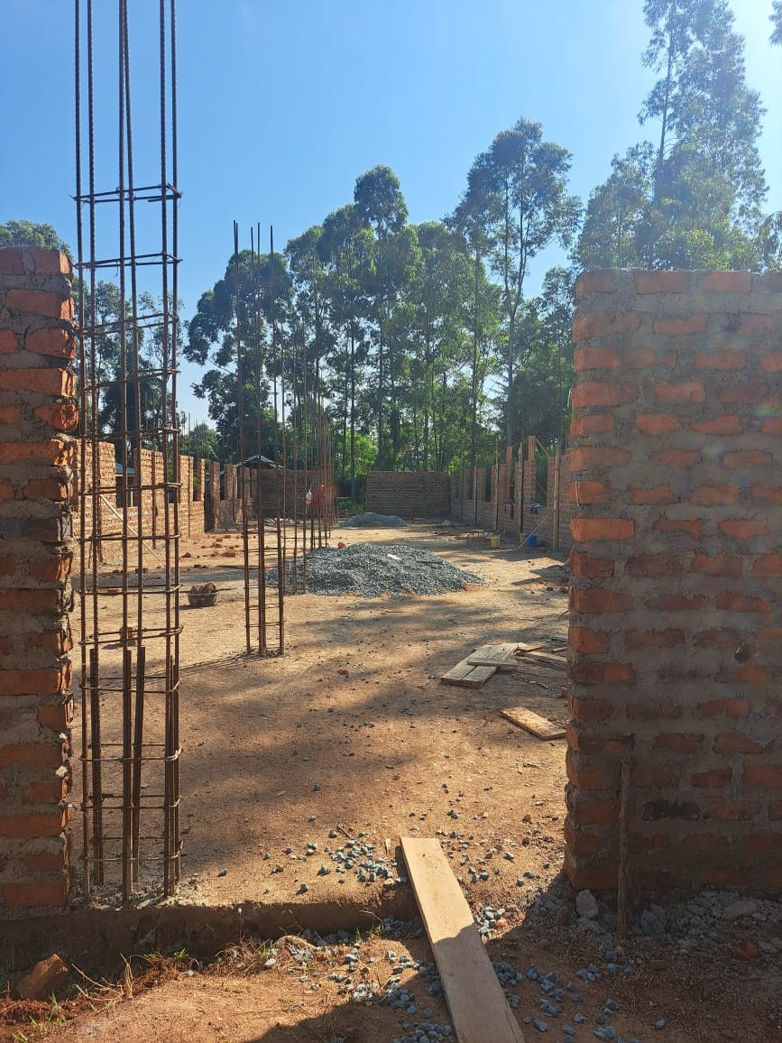
A dormitory under construction to accommodate the growing number of Students

OBER BOYS HIGH SCHOOL STRATEGIC DEVELOPMENT PLAN (2023 – 2027) 07 | Page


Table 6:
Curriculum Based Establishment for Senior Master/Mistress as at Decembe2r 202
OBER BOYS HIGH SCHOOL STRATEGIC DEVELOPMENT PLAN (2023 – 2027)
08 | Page

ITEM  NO | DEPARTMENT | NAME OF SENIOR  MASTER/MISTRESS | GENDER | YEAR OF  GRADUATION | YEARS OF  EXPERIENCE IN TEACHING | YEARS OF  EXPERIENCE AS HOD | SUBJECT  COMBINATION
1) | Humanities | Mrs. Joyna Owino | Female | 2007 | 13 | 9 | GEO / BST
2) | Sciences | Mr. Robins Ouma | Male | 2007 | 13 | 8 | CHE / BIO
3) | Mathematics | Mr. Bob Obonyo | Male | 2012 | 11 | 4 | PHY / MAT
4) | Languages | Mr. George Ngoko | Male | 2013 | 8 | 6 | ENG / LIT
5) | Technical and Creative  Arts | Mr. Blasius Binda | Male | 2018 | 5 | 3 | BST / MAT
6) | Boarding | Mr. Joshua Odero | Male | 2009 | 11 | 9 | BIO / CHE
7) | Co- curriculum  Activities/Games | Mr. Phelix Ajimo | Male | 2016 | 7 | 5 | AGR / BIO
8) | Guidance and  Counseling/ Careers | Mrs. Christine Owande | Female | 2015 | 6 | 3 | AGR / BIO
9) | Quality Assurance and  Standards (QAS)/Head of Examinations | Mr. Lurban Aol | Male | 2019 | 2 | 1 | PHY / MAT
10) | Academic Mentorship  &Director of Studies | Mr. George Ngoko | Male | 2013 | 8 | 6 | ENG / LIT
Source: School data, 2022

1.1.1.Gaps in the CBE
From the review of the TSC Policy on CBE for Secondary schools in Kenya, the School has identified a huge discrepancy in CBE as follows:

Table 7: CBE per Department by No. of Staff be Department (Current and Projected)

Department | CBE as at 2022 | Projected CBE  as at 2027 | Existing Gap  in CBE
Humanities | 14 | 19 | 5
Science and Mathematics | 29 | 40 | 11
Languages | 19 | 26 | 7
Technical and Creative Arts | 14 | 20 | 6
Boarding | 10 | 15 | 5
Co- curriculum Activities/Games | 20 | 24 | 4
Guidance and Counseling/ Careers | 28 | 37 | 9
Quality Assurance and Standards  (QAS)/Head of Examinations | 4 | 6 | 2
Academic Mentorship & Director of  Studies | 2 | 4 | 2
Source: School data, 2022
    - ShortTerm Interventions to address CBE Gaps
To address the CBE gaps, the school has taken several measures and tapped from specific Government interventions as follows:
      - BOM Teachers
With the current student population of 1,608, the school ought to have a total teaching staff of 76 against the current 22 TSC employed teaching staff. However, owing to resource limitation and need to optimize resource utilization, the school has set its optimal CBE at 68 TSC employed teachers using 8 streams cap. The current number of TSC teachers is 22 leaving a shortfall of 46.To address this crucial gap that negates the TSC Policy of CBE (2017, 2022), the Board of Management of Ober Boys' High School has employed a total of 22 teachers on BOM Terms of Service to complement the TSCTeachers.The school also engages some of its 10 best former students (old boys) during campus breaks to assist with marking subjects and guide comrades with revision /mentorship at a commensurate rate of Kshs. 8,000 per month excluding full course meals and accommodation provided by the school within the compound.

Despite the above interventions of the BOM and the School, there is still a huge gap in achieving required CBE for the school.This has led to heavy work load on both TSC and BOM teachers which now calls for additional topical time table arrangements to increase Teacher-Learner Contact Hours.
During 2023 – 2027, the school will seek closer and heightened working relationship with the TSC and the BOM towards ensuring that the CBE requirement for the school remained congruent with the student population growth trends. It is envisaged that within the new Strategic Plan Implementation period, the school will be able to acquire at least additional 41 TSC employed teachers. The deficit of the teaching staff and non-teaching staff shall then be filled through Board intervention such the school is in full compliance with the TSC CBE Policy (2017, 2022) and the Kilemi Mwiria Report (2014).

OBER BOYS HIGH SCHOOL STRATEGIC DEVELOPMENT PLAN (2023 – 2027) 09 | Page


      - Teachers onTeaching Practice (TP)
The school has been a destination of choice for Trainee Teachers from both public and private universities and teacher training colleges in Kenya.The table 7 below summarize the number of Teachers on TP received by the school per year by their origins (names of universities/colleges) where they came from as well as their subject combinations and gender.

Table 8:Teachers onTP received by the school per year by their origins (names of universities/colleges)

NAME OF UNIVERSITY  / COLLEGE | No. of TTPs Received |  |  |  |  | Projected TTPs In-flows in the next Strategic Planning Phase
NAME OF UNIVERSITY  / COLLEGE | 2018 | 2019 | 2020 | 2021 | 2022 | 2023 | 2024 | 2025 | 2026 | 2027
University of Nairobi (UoN) | 2 | 2 | 0 | 3 | 3 | 2 | 2 | 2 | 3 | 3
Kenyatta University (KU) | 2 | 2 | 0 | 3 | 4 | 2 | 2 | 3 | 3 | 3
Moi University | 1 | 1 | 0 | 1 | 2 | 1 | 2 | 2 | 2 | 2
Egerton University | 1 | 2 | 0 | 2 | 2 | 1 | 1 | 1 | 2 | 2
Kisii University | 0 | 0 | 0 | 1 | 1 | 1 | 1 | 2 | 2 | 2
South Eastern Kenya University (SEKU) | 0 | 0 | 0 | 0 | 0 | 0 | 0 | 0 | 0 | 0
Pwani University | 0 | 0 | 0 | 0 | 0 | 0 | 0 | 0 | 0 | 0
Chuka University | 0 | 0 | 0 | 0 | 0 | 0 | 0 | 0 | 0 | 0
Karatina University | 0 | 0 | 0 | 0 | 0 | 0 | 0 | 0 | 0 | 0
Kenya Methodist University (KEMU) | 0 | 0 | 0 | 0 | 0 | 0 | 0 | 0 | 0 | 0
Rongo University (RU) | 2 | 3 | 3 | 2 | 2 | 3 | 3 | 3 | 3 | 3
Maseno University | 4 | 3 | 3 | 3 | 3 | 3 | 3 | 3 | 3 | 3
Masinde Muliro University of Science and  Technology (MMUST) | 1 | 2 | 0 | 1 | 1 | 2 | 2 | 2 | 2 | 2
Tom Mboya University (TMU) | 0 | 0 | 0 | 0 | 0 | 2 | 2 | 2 | 2 | 2
Catholic University of Eastern Africa (CUEA) | 0 | 0 | 0 | 0 | 0 | 0 | 0 | 0 | 0 | 0
University of Eastern Africa Baraton | 0 | 0 | 0 | 0 | 0 | 0 | 0 | 0 | 0 | 0
Kabarak University | 0 | 0 | 0 | 0 | 0 | 0 | 0 | 0 | 0 | 0
Meru University of Science and Technology  (MUST) | 0 | 0 | 0 | 0 | 0 | 0 | 0 | 0 | 0 | 0
University of Kabianga | 0 | 0 | 0 | 0 | 0 | 1 | 1 | 1 | 1 | 1
Maasai Mara University, Narok | 0 | 0 | 0 | 0 | 0 | 0 | 0 | 0 | 0 | 0
Laikipia University | 0 | 0 | 0 | 0 | 0 | 0 | 0 | 0 | 0 | 0
Tharaka University College | 0 | 0 | 0 | 0 | 0 | 0 | 0 | 0 | 0 | 0
Mount Kenya University (MKU) | 0 | 0 | 0 | 1 | 1 | 1 | 1 | 1 | 1 | 1
Kaimosi Friends University College | 0 | 0 | 0 | 0 | 0 | 1 | 1 | 1 | 1 | 1
Alupe University College, Busia | 0 | 0 | 0 | 0 | 0 | 0 | 0 | 0 | 0 | 0
Prysbyterian Teachers College Rubate, Chuka | 0 | 0 | 0 | 0 | 0 | 0 | 0 | 0 | 0 | 0
Chepkoilel University College, Eldoret | 1 | 0 | 0 | 1 | 1 | 1 | 1 | 1 | 1 | 1
Kibabii University, Bungoma | 0 | 0 | 0 | 0 | 0 | 1 | 1 | 1 | 1 | 1
Marist International University College, Nairobi | 0 | 0 | 0 | 0 | 0 | 0 | 0 | 0 | 0 | 0
Umma University, Kajiado | 0 | 0 | 0 | 0 | 0 | 0 | 0 | 0 | 0 | 0
Tangaza University, Nairobi | 0 | 0 | 0 | 0 | 0 | 0 | 0 | 0 | 0 | 0
Gretsa University | 0 | 0 | 0 | 0 | 0 | 0 | 0 | 0 | 0 | 0
Machakos University | 0 | 0 | 0 | 0 | 0 | 0 | 0 | 0 | 0 | 0
Garisa University | 0 | 0 | 0 | 0 | 0 | 0 | 0 | 0 | 0 | 0
Other Colleges and Institutes | 2 | 3 | 0 | 3 | 2 | 2 | 2 | 2 | 2 | 2
TOTAL | 16 | 18 | 6 | 21 | 22 | 24 | 25 | 27 | 29 | 29
Source: School data, 2022

OBER BOYS HIGH SCHOOL STRATEGIC DEVELOPMENT PLAN (2023 – 2027) 10 | Page

From the table 7, we are able to see the Training Institutions that have trusted and continue trusting Ober Boys' High School with Professional development of their trainee teachers. It is the hope of the school that as projected, the school shall continue receiving trainee teachers from the institutions listed above as primary sources while making inroads to institutions that are yet to send their students to Ober Boys' High School.This partnership shall be crafted, nurtured and sustained, not only as a source of human resource to bridge the CBE gap, but also in line with the school's overall goal of aligning the school development priorities and activities with its core focus of academic, behavioral and environmental excellence, thereby providing for its continued survival, effectiveness, efficiency and accountability while effectively contributing to human resource development in the education sector in Kenya.

      - TSC InternTeachers
The Ministry of Public Service, Gender and Affirmative Action of the Republic of Kenya is tasked with the responsibility of ensuring that the Kenyan Government policy on provision of practical skills to graduates to enable them gain work related experience as a way of increasing their employability thus reducing the rate of unemployment in Kenya is implemented in Kenya. This has been done through various Internship programs offered by Ministries, Departments, Agencies and County Governments (MDACs). Currently, the Public Service Internship Policy and Guidelines for the Public Service (PSC,2016) is being implemented across the Public Service. Other existing Internship policies and guidelines include the Health Workers Internship Programme;Teaching Service Internship Programme implemented in Kenya by the TSC; Pupilage and Post Pupilage Programmes under the Kenya School of Law among others.

Ober Boys' High School has in the past benefited fromTSC posted interns as follows:-

Table 9:Actual and ProjectedTSC InternTeachers byYear

 | No. of Interns Received in the Period  2018 – 2022 |  |  |  |  | Projected Interns In-flows in the  next Strategic Planning Phase
 | 2018 | 2019 | 2020 | 2021 | 2022 | 2023 | 2024 | 2025 | 2026 | 2027
NO. OF TSC INTERNS | 0 | 1 | 0 | 2 | 0 | 2 | 2 | 2 | 2 | 2
Source: School Data, 2022

OBER BOYS HIGH SCHOOL STRATEGIC DEVELOPMENT PLAN (2023 – 2027) 11 | Page


CHAPTER TWO

STRATEGIC STATEMENTS & STATEMENT OF INTENT
  - Purpose Statement
The purpose of the School Strategic Development Plan (2023 – 2027) is to enable stakeholders to agree and specific actions that will contribute to the growth and development of the school in desired direction, align resources for optimal results within the Planning parameters and framework, prioritize school financial needs and resources for best value for money while working towards build competitive advantage and engaging all education and school stakeholders on what needs to be done and that must be done to realize the school vision and strategic goal and objectives as outlined in the Strategy.The Plan is also intended to aid risk reduction, quality standards assurance, mitigate uncertainty and implement sound risk assessment and reduction measures while assuring investors of the best outputs and outcomes through effective and efficient Strategic Development Plan Implementation.
The plan therefore positions the school for excellence in the delivery of teaching, facilitation of learning, knowledge and skills transfer as well as holistic child development and orientation for optimal performance in the life after school and high affinity to the demands of the post 21st Century Digital Age.
  - Vision Statement
To be a Center of Excellence in the Provision of Quality Inclusive Education and Holistic Learner Development.
  - Mission Statement
To provide, promote and coordinate effective and efficient implementation of Competency- Based Curriculum in provision of equitable learner centered education, holistic learner development while inculcating a culture of discipline, hard work, creativity, innovation, research and resilience for optimal learner performance in the post 21st Century Digital Age.
  - Overall Goal
The overall goal of the Strategic Development Plan (2023 – 2027) is to align the school development priorities and activities with its core focus of academic, behavioral and environmental excellence, thereby providing for its continuing survival, effectiveness, efficiency and accountability.
  - Strategic Objectives
    - Strategic Objective 1: Develop a School Culture andTradition
    - Strategic Objective No. 2: Achieve and sustain excellence in academic performance at all levels (Form I – IV), attaining MSS of at least 9.5 in subsequent KCSE Exams year-on.
    - Strategic Objective No. 3: Improve, Expand and Maintain Adequate School Infrastructure for Delivery of Quality Education in a conducive and livable learning environment Strategic Objective No. 4: Achieving Excellence in Co-curricular activities including drama, games, sports and athletics
    - Strategic Objective No. 5: Achieving Excellent Environmental Quality and Contribution to Climate Change Risks Mitigation

OBER BOYS HIGH SCHOOL STRATEGIC DEVELOPMENT PLAN (2023 – 2027) 12 | Page

  - Specific Objectives
The current strategic development plan shall pursue the following strategic development objectives:-
- Increase Enrolment from 1,986 in 2022 to 2,600 in 2027
- Increase and Sustain School Overall Performance MSS at or above 9.0 annually
- Increase the number ofTSC employed teachers from 22 as at 2023 to 50 by end of 2027
- Decongest Mt. Carmel, Mt. Kenya and Mt Everest Hostels by constructing to completion 1no triple story Hostel with capacity for 500 double decker bed occupancy.
- Improve subject Standard Mean Scores for STEM Subjects as follows: Math – 7.0, Biology – 8.5, Physics 10.25, Chemistry - 8.5, English – 9.45 by end of 2027.
- Improve availability of quality and quantity safe drinking and other utility-purpose water through enhanced roof-top water harvesting, storage, treatment and distribution as well as by drilling a 200 meters deep borehole complete with a reticulation system including water kiosks.
- Construct additional three (3) classrooms annually
- Construct 20 – door students' latrines with bio-digester component for production of extra cooking gas
- Install Solarmax 52KVA Solar Back Up System with Hybrid Inverter to provide clean renewable lighting and heating energy
- Construct 8nos Science Laboratories to boost STEM subjects by end of 2027
- Construct, Furnish, Equip and Stock a 500-capacity school library,
- Construct 10nos single-bedroom staff houses annually for a period of 4 years
- Construct, furnish, and equip Food andTools/Equipment/Apparatus Stores in conformity to Code of Regulations for Building and Construction such facilities within schools;
- Enlarge and modernize food serving areas to ensure the children are protected for scorching sun or torrential rains
- Acquire 1 unit of 17-seater Coaster School and a Single-Cab School Pick-UpVans to improve mobility and service delivery in the school.
- Construct a modern school administration block with provisions for Principal's Office, Deputy Principal's Office, Director of Studies' Office, Head Examiner's Office, School Bursar's/Cashier's Office, a Staff Room, a Strong Room/Store, a Board Room and Conference Room and a reception area.
- Promote ICT integration in teaching and learning
- Promote school greening program through planting of shade, fruit, indigenous an exotic/commercial trees.

OBER BOYS HIGH SCHOOL STRATEGIC DEVELOPMENT PLAN (2023 – 2027) 13 | Page

2.7. Projected Enrolment/Students’ Population (2023 – 2027)
During the 2023 – 2027 Planning Period, the school enrolment is envisaged to grow and expand as per the table 9 below:
Table 10: Project Enrolment vs Classes Expansion Needs between 2023 - 2027
OBER BOYS HIGH SCHOOL STRATEGIC DEVELOPMENT PLAN (2023 – 2027)
14 | Page

FORM/ CLASS | 2023 |  | 2024 |  | 2025 |  | 2026 |  | 2027 |  | OPTIMUM ENROLMENT
FORM/ CLASS | STREAMS | ACTUAL | STREAMS | ACTUAL | STREAMS | ACTUAL | STREAMS | ACTUAL | STREAMS | ACTUAL | OPTIMUM ENROLMENT
I | 8 | 608 | 8 | 650 | 9 | 700 | 10 | 700 | 10 | 700 | 700
II | 8 | 606 | 8 | 603 | 8 | 650 | 9 | 650 | 10 | 650 | 650
III | 7 | 454 | 8 | 607 | 8 | 603 | 8 | 650 | 9 | 650 | 650
IV | 5 | 296 | 7 | 454 | 8 | 600 | 8 | 600 | 8 | 650 | 650
TOTAL | 28 | 1,964 | 31 | 2,314 | 33 | 2,553 | 35 | 2,600 | 37 | 2,600 | 2,600
ADDITIONS  (STUDENTS VS CLASSES) |  |  | 3 | 351 | 2 | 239 | 2 | 286 | 2 | 0 | 0
NOTE: | The above projections are based on the imperative need to peg admissions on physical infrastructure expansion and development while b eing alive to the need  to “LEAVE NO CHILD BEHIND” as espoused by the 100% Transition Policy and Transition from 8.4.4 to 2.6.6.3 CB C program. We are committed to support the implementation of these policies as we endeavor to produce holistically oriented children that will be best-fit for the post 21st Century Digital Economy.

  - Projected Academic Performance by Posted KCSE Mean Standard Scores
(2023 – 2027)
As at close of the 2018 – 2027 Plan Implementation period, the school recorded a marked improvement in its academic performance, rising from a MSS of 4.6 in 2018 to 8.8 in 2022. In the 2023 – 2027 Strategic Planning Period, the projected MSS shall be pegged on specific parameters for excellent academic performance in National Qualifier Exams that include the following: - regular studying, self-motivation, punctuality and regular class attendance, hard- work, ability to build interest in a subject, the availability of teaching and learning materials, students' personality traits, accurate setting of personal goals, learner-centered pedagogical approaches, prompt response to learner's needs in and out of class, and teachers' levels of experience and content mastery. With these in mind, the school, using 2022 KCSE performance outcomes, has set the following 5-year targets as a measure of its commitment to the vision and mission statement of the school:-
Table 11: Actual vs Projected MSS,Total Candidates Enrolled and % Transition to Varsities per annum

 | ACTUAL MEAN STANDARD SCORE |  |  |  |  | PROJECTED MEAN  STANDARD SCORE
 | 2018 | 2019 | 2020 | 2021 | 2022 | 2023 | 2024 | 2025 | 2026 | 2027
KCSE Mean Standard Scores | 5.7702 | 5.4922 | 6.3757 | 8.8019 | 8.6400 | 9.600 | 8.854 | 9.802 | 9.831 | 9.866
Total No. Of Candidates  Enrolled | 161 | 193 | 189 | 207 | 208 | 296 | 450 | 598 | 600 | 605
Total No. Of Candidates  Qualifying for Direct University Admissions | 47 | 49 | 76 | 198 | 205 | 290 | 396 | 568 | 571 | 577
Percentage Transition to  University P.A. | 29.19 | 25.39 | 40.21 | 95.65 | 98.56 | 97.97 | 88.00 | 94.98 | 95.17 | 95.37
Source: School Data, 2022
  - Projected CBE by Employer (TSC/BOM) for the Period, 2023 – 2027
As per table 4 in this Strategic Development Plan (see below), and going by the projected student and infrastructure development, expansion and growth plan herein, it is expected that TSC shall live to its own Policy Provisions on CBE for Extra County Schools with student population of 1,980 and above. This implies that the school will continue attracting TSC employed teachers starting May 2023 to December 2027 until an optimal CBE of 93 TSC Teaching Staff for a student population of 1,980 is thereby attained. It is also envisaged that the school resources at the disposal of the BoM shall capacitate the BoM to hire extra teaching and non-teaching staff to optimize the school's CBE requirement, therefore improve school's capacity for effective supervision, teaching, learning and students' assessment programmes.

Table 12: TSC Approved CBE Establishment for Secondary Schools in Kenya

No. of  Streams | Classes | Maximum Enrolment | CBE | No. of Deputy  Principals | No. of Senior  Masters/ Mistresses
1 | 4 | 180 | 9 | 1 | 1
1. | 8 | 360 | 19 | 1 | 2
2. | 12 | 540 | 28 | 1 | 4
3. | 16 | 720 | 38 | 1 | 5
4. | 20 | 900 | 47 | 1 | 6
5. | 24 | 1080 | 55 | 2 | 6
6. | 28 | 1260 | 63 | 2 | 7
7. | 32 | 1440 | 68 | 2 | 7
8. | 36 | 1620 | 76 | 2 | 7
9. | 40 | 1800 | 85 | 2 | 8
10. | 44 | 1980 | 93 | 2 | 9
11. | 48 | 2160 | 101 | 2
[Source:TSC, 2017, 2022]

OBER BOYS HIGH SCHOOL STRATEGIC DEVELOPMENT PLAN (2023 – 2027) 15 | Page

Table 11 gives the TSC's ideal school staffing levels that will guide staffing and infrastructure growth and development at Ober Boys High School during the Plan implementation period as follows:
- No. of streams to grow to optimal capacity of between 8 and 12 streams to accommodate the growing population of students as perTable 10; and
- Actual number of classes to grow exponentially with the expansion in the number of streams and students' population (SeeTable 10).
- TSC Employed teachers to increase from the current 22 to 68 by the end of the Plan implementation period (2027).
- The school to have 2 Deputy Principals in-charge of Academic Affairs and Administration Affairs respectively by the end of 2023.

2.1.10 Justification of the School Strategic Plan (2023 – 2027)
The structure, content and strategies of the Strategic Plan is designed and espoused to help the school and its administration to carry out its mission, vision, and live its values (OBER). The document is also intended to help the school to comply with mandates and regulations of government as is bestowed upon the Ministry of Education and implemented through its various agencies and organs for the purpose of seamless transition from the 8.4.4 to the 2.6.6.3 curriculum framework.The Strategy also hopes and intends to keep the school operationally and fiscally healthy, now and in the future, thereby being above its peers when it comes to the implementation of TSC Performance Contracts for School Principal, Senior Masters/Mistresses,Teachers and Support Staffs within the confines of theT-PAD.

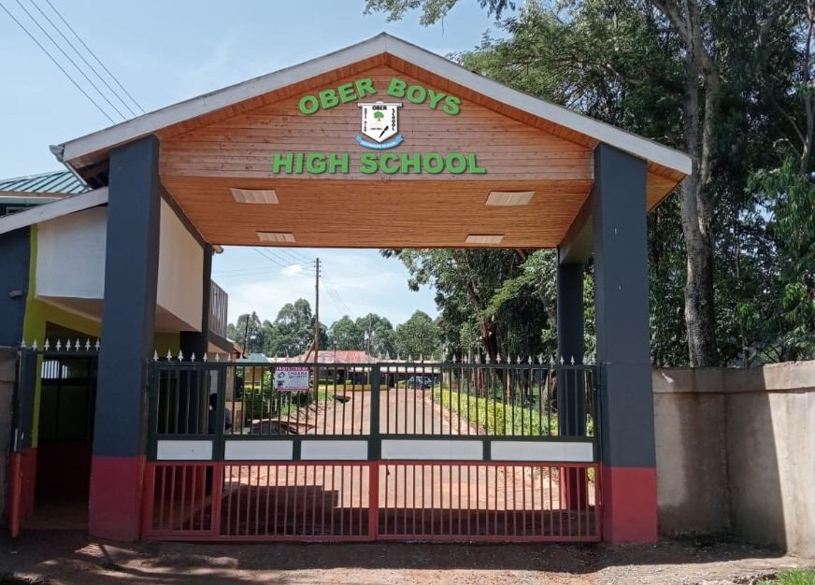

OBER BOYS HIGH SCHOOL STRATEGIC DEVELOPMENT PLAN (2023 – 2027) 16 | Page

CHAPTER THREE

LEGAL AND POLICY FRAMEWORK FOR STRATEGIC PLANNING

Introduction
The Ober Boys' High School Strategic Development Plan (2023 – 2027) is founded on the principal targets of Sustainable Development Goal No. 4 (SDG4) on quality education for sustainable development. The Strategic Plan is designed to contribute to the realization of global (SDG #4), Continental (African Union's Continental Education Strategy for Africa (CESA), Regional (Intergovernmental Authority on Development – IGAD – Regional Education Policy Framework), East Africa Community (EAC Education Curriculum Harmonization Program), the Constitution of Kenya Article 35 (3) and A Policy Framework for Education and Training: Reforming Education and Training in Kenya among other policy instruments.The commitment of the school to these policies and legal frameworks is so crucial in the process of building sub-national and national synergies towards achieving the SDG4 targets and Aspiration 1 of the AU Agenda 2063 within the framework of Kenya's Education Sector Strategic Plan and Sector Policies.

Kenya Education Sector Legal and Policy Framework
Kenya has ratified most of the international treaties and agreements that protect the right to education and that to a large extent now form part of the country's laws.The Constitution of Kenya, in Article 53 (1) (b), in particular, state that every child has a right to free and compulsory basic education and Article 55 (a) compels the State to take general and specific measures, including affirmative action programmes, to ensure that the youth access relevant education and training. Minorities and marginalized groups under Article 56 (b) have a right to be provided with special opportunities in the field of education.

To give effect to the Constitution, the Basic Education Act (No 14 of 2013) was passed into law to regulate the provision of basic education and adult basic education in the country. The Children's Act, 2001 also acknowledges and protects every child's right to education. Other education laws guarantee the implementation of the right to education.

In addition, Kenya adopted various general and specific policies on education.The most recent are the third Medium Plan Term ofVision 2030 (2018), the Policy Framework for Education and Training (2012) and the Education Sector Medium Term Expenditure Framework 2023/24 – 2025/26 (GOK, 2022 still under development). Kenya recognizes that education is the key for empowering the most marginalized and vulnerable individuals in society and make efforts on an affirmative basis to enable these individuals to best exploit their life-chances alongside their other Kenyan peers through primary, secondary and tertiary education.

The 2012 Policy Framework for Science,Technology and Innovation is a policy in time that is giving strong bearing to the Vision Statement of Ober Boys' High School, that is, “aims at providing the national policy framework to acquire, develop and promote science, technology and innovation for national transformation to a knowledge economy. It aims to mainstream application of science, technology and innovation for national transformation to a knowledge economy. It aims to mainstream application of science, technology and innovation in all sectors and processes of the economy to ensure that Kenyans benefit from acquisition and utilization of available capacities and capabilities to achieve the objectives of KenyaVision 2030. However, Kenya acknowledges the challenge of lack of integration of culture in the formal education system which impedes cultural creativity and expression.

OBER BOYS HIGH SCHOOL STRATEGIC DEVELOPMENT PLAN (2023 – 2027) 17 | Page

Policies guiding schools' strategic planning in Kenya are based on the Kenya's Policy Framework for Education (2012) that seeks to aligning Education andTraining to the Constitution of Kenya (2010) and Kenya Vision 2030 and beyond.The policy also seeks to enable Kenya to meet its international commitments with regards to provision of quality education in accordance with the provisions of Article 35 (3) of the Kenya Constitution 2010, in particular, the goals and objectives of the Sustainable Development Goals (SDG4) and the aspirations of the Global Education Programme (GEP) both of which obligate contracting parties to spread the benefits of an all-inclusive, holistic and education to every citizen of the country that is oriented towards driving the sustainable development agenda through science, innovation and technology with much attention to conservation and sustainable use of natural and environmental resources.
Kenya's Policy Framework on Education and Training: Reforming Education and Training in Kenya upon which this Strategic Plan draws its strength, has enabled the encapsulation of the ideas and principles that should guide the educational sector institutions' policies, programmes and initiatives that the Government, through the Department of Education, ought to support in order to effectively meet the emerging education needs and aspirations of the Kenya.
It is on the basis of the foregoing education policy framework in Kenya that the Board of Management of Ober Boys' High School has developed its vision and mission statements to be in line with Kenya's Education Sector Aspirations and to position the school for excellence in the provision of quality inclusive education and holistic learner development for sustainable development. The vision shall be pursued through the school mission that seeks to provide, promote and coordinate the effective and efficient implementation of a Competency-Based Curriculum in the provision of equitable quality learner-centred education and holistic learner development while inculcating a culture of obedience, boldness, earnestness, responsibility, discipline, hard work, creativity, innovation, research and resilience for optimal learner performance in the post 21st Century Digital Age.
  - African Union's Continental Education Strategy for Africa (CESA 16-25) CESA (16-25) is a ten-year continental education strategy that was presented to the Council of Ministers for adoption as a response to the Aspiration 1 of the AUAgenda 2063. It is in line with the Global Education 2030 Programme and contributes to the achievement of objective 4 of the SDGs. CESA 16-25 calls for a paradigm shift towards transformative education and training systems to meet the knowledge, competencies, skills, research, innovation and creativity required to nurture African core values and promote sustainable development. The achievement of Aspiration 1 of Agenda 2063 for “A prosperous Africa based on inclusive growth and sustainable development” requires that Africa makes significant investments in education with the aim of developing human and social capital through an education and skills revolution emphasizing innovation, science and technology. The AU Continental Education Strategy for Africa (CESA) aims to reorient Africa's education and training systems to meet the knowledge, competencies, skills, innovation and creativity required to nurture African core values and promote sustainable development at the national, sub-regional and continental levels.
The key objectives of CESA are to: - (a) Revitalize the teaching profession to ensure quality and relevance at all levels; (b) Expand access to quality education by building, rehabilitating, and preserving education infrastructure and developing policies that ensure a permanent, healthy and conducive learning environment in all sub-sectors; (c) Harness the capacity of ICT to improve access, quality and management of education and training systems; (d) Ensure acquisition of requisite knowledge and skills as well as improved completion rates at all levels

OBER BOYS HIGH SCHOOL STRATEGIC DEVELOPMENT PLAN (2023 – 2027) 18 | Page

and groups through harmonization processes across all levels for national and regional integration; (e) Accelerate processes leading to gender parity and equity; (f) Launch comprehensive and effective literacy campaigns across the continent to eradicate illiteracy; (g) Strengthen the science and math curricula and disseminate scientific knowledge and the culture of science in the African society;(h) ExpandTVET opportunities at both secondary and tertiary levels and strengthen linkages between the world of work and education and training systems;
(i) Revitalize and expand tertiary education, research and innovation to address continental challenges and promote global competitiveness; (j) Promote peace education and conflict prevention and resolution at all levels of education and for all age groups; (k) Build and enhance capacity for data collection, management, analysis, communication, and improve the management of education system as well as the statistic tool, through capacity building for data collection, management, analysis, communication, and usage; and (l) Set up a coalition of all education stakeholders to facilitate and support initiatives arising from the implementation of CESA.
The current School Strategic Plan has its Specific Objectives are coiled around the AU Agenda 2063 and the Continental Education Strategy for Africa (CESA).The objectives are also in line with IGAD, EAC and Kenya's Education Sector Strategy towards the 2030 SDG#4 agenda as espoused in the Global Education Program (GEP).

The IGAD Education Policy Framework
The Intergovernmental Authority on Development (IGAD) was established in 1986 to respond to drought, desertification, famine and related disasters by coordinating regional cooperation among Member States and partners, Kenya being one of the key Member States in IGAD. Its revitalization in 1996 reinforced these interventions and expanded IGAD's mandate to provide leadership in a wide-range of development sectors focusing on peace and security; agriculture, food security, climate change and environmental protection; economic cooperation and regional integration; as well as health and social development – within which Division of IGAD that Education and Training falls.The region is home to over 260 million people, of which 60 to 70 percent are youth and school-age children.
The IGAD Regional Education Policy Framework aspires to address the concerns of this large segment of the population by advocating for accessible, equitable, relevant, inclusive and quality education in all the Member States, imperatives which have guided the formulation of the 2023 – 2027 Strategic Development Plan for Ober Boys' High School and which will guide its implementation as the school expands in partnership and collaboration base with its primary stakeholders as it seeks wider collaborations and partnerships with other development partners and donors – locally and internationally. The IGAD Education Sector Policy Framework is broad enough to provide directions to all sectors and levels of education. It reflects the key priority areas identified in national, regional/continental, and international instruments in this field.
  - United Nations Sustainable Development Goal No. 4: Quality Education The SDG #4 is so central to any meaningful education sector policy formulation, legislation and development program. It calls for all nations to ensure no child is left behind when it comes to accessing quality education. One central focus of the SDG #4 is the call on states and governments to build and upgrade education facilities that are child, disability and gender sensitive and to provide safe, non-violent, inclusive and effective learning environments for all by the year 2030.The SDG #4 further calls upon states and governments to ensure that by 2030, there shall be a substantial increase in the supply of qualified teachers, including through international cooperation for teacher training in developing countries, especially least developed countries and small island developing States.

OBER BOYS HIGH SCHOOL STRATEGIC DEVELOPMENT PLAN (2023 – 2027) 19 | Page

The School Strategic Development Plan's strategic objectives has taken into account the SDG # Targets and Outcomes including:
- The urgent need for adequate physical infrastructure – tuition; accommodation and welfare; Water, sanitation and hygiene;
- Ensuring a safe, inclusive environments that nurture learning for all, regardless of background or disability status;
- The urgent attention, with a more immediate deadline, on CBE optimization with adequate support and motivation to both teaching and non-teaching staff. The focus on staffing and staff capacity building during the Planning Period, 2023 – 2027, is given much emphasis because the equity gap in education is exacerbated by the shortage and uneven distribution of professionally trained teachers where student population is growing steadily yet supply of teachers remains below approved CBE standards.
The UN SDG #4 therefore asserts that teachers are a fundamental condition for guaranteeing quality education, teachers and educators should be empowered, adequately recruited and remunerated, motivated, professionally qualified, and supported within well-resourced, efficient and effectively governed systems.
  - Implications of the Strategic Plan on Legal and Policy Environment
The Ober Boys' High School Strategic Development Plan (2023 – 2027) is a management decision-making tool and organizational development framework that is fully aligned major policy and legislation frameworks at global, continental, regional and national level with a sharp focus on building on the successes of the previous Strategic Plan (2018 – 2022) while forecasting its priorities on preparation for the full-scale roll-out of the Competency-Based Education Curriculum in Kenya.The Strategic Plan is therefore quite cognizant of the need for effective and broad-based preparation to cushion the school from boomerang effects of the Compulsory and Free Basic Education and its 100%Transition policy.This is to be achieved through 7 pillars:
- Access – Increased Enrollment, Retention and Completion of Education Cycle
- Quality – Infrastructure, Pedagogical Approaches, Guidance & Counseling, Co-
Curricular Activities and Career development
- Equitable – Implementation of fair admission policies that gives every child an equal chance to join and learn at Ober Boys' High School
- Relevant – Ensure the curriculum implementation is in full compliance with Quality Assurance Standards and strictly follows the approved national secondary education curriculum as provided by the Government of the Republic of Kenya.
- Inclusive – The school principal shall strive to guarantee the following attributes of an inclusive education: - administrative support, teacher attitude and motivation, parental support and involvement, collaboration and networking, and promote best classroom practices at all times to ensure best outcomes at the end of each term/year.
- Holistic – The school adopts the UNESCO definition of holistic learning as a learning approach that activates the learner's intellect, emotions, imagination and body for more effective and comprehensive learning. In practice, the school, during the 2023 – 2027 Plan Implementation Period, shall strive towards main streaming the concept holistic education—the philosophy of educating the whole person, beyond core academics— to build a crop of a generation that is has strong foundation in a core curriculum, ready to be part of the global solutions to global problems through the invocation of their innovation, creativity, critical thinking, team building, conflict management and resolutions as well as ability to remain active in environment and nature conservation among other features of a holistically educated and nurtured child for the post 21st Century.

OBER BOYS HIGH SCHOOL STRATEGIC DEVELOPMENT PLAN (2023 – 2027) 20 | Page

- Service-Oriented:-The current plan recognizes the role a school plays in cultivating patriotism attitude in learners. During the Plan Implementation Period, 2023 – 2027, the school shall explore programs and activities that inculcates more patriotism attitudes in our learners. Clubs shall be strengthened and supported to carry out their respective mandates, both within and outside the school.
3.1. Conclusion
In conclusion, the school observes that no action in and or outside the school is isolated from the Global, Continental, Regional, National and Local education sector development policies and legislative frameworks. It is in this realization that the Strategic Plan has sought to align itself with all application policy and legislation instruments.This is considered vital in the pursuit of development priorities now outlined in the Chapter Four (4) of the Strategic Plan through the invocation of SDG # 17: Partnerships for Development. It is the hope of the school that it primary partners: Ministry of Education, Ministry of Health, Ministry of Water, Ministry of Energy, Ministry of Environment through NEMA and all related State Departments and Agencies as well as other independent local and international development partners shall find this Strategic Plan useful in determining their resource mobilization and allocation strategy in so far as our school is concerned.
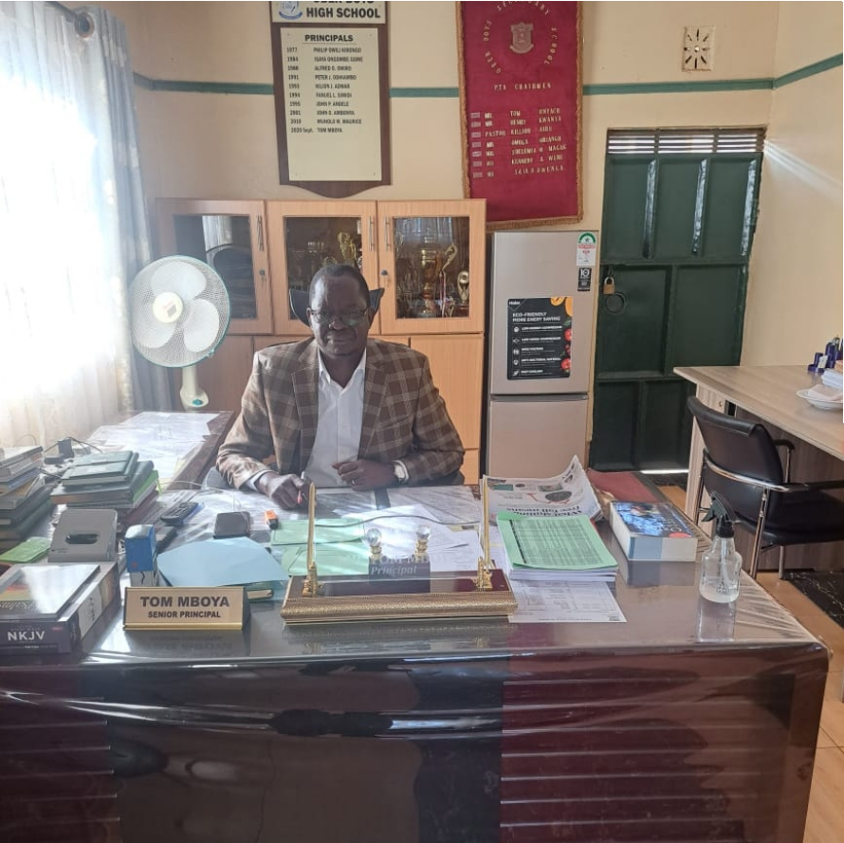

OBER BOYS HIGH SCHOOL STRATEGIC DEVELOPMENT PLAN (2023 – 2027) 21 | Page

CHAPTER FOUR

COORDINATION AND IMPLEMENTATION FRAMEWORK.

Overview
This chapter provides for the strategy implementation approach; institution's governance structure; projected optimal staffing levels and human resource capacity; effective performance management system; financial resources and resource management of school resources; staff attitude and motivation strategies; ICT integration and use in teaching, learning, exam administration and school management; school stakeholder analysis and management; collaboration, networking and partnership strategies; strategies for resource mobilization and financial sustainability as well as the risk management strategy. It also details the success factors in the implementation of the Plan.

Strategy Implementation Approach
    - The Ministry of Education, Science and Technology, through the State Department of Early Learning and Basic Education, shall remain committed to the Kenya National Education Policy Framework and release resource due to the school in good time, besides resourcing the school with grants-in-aid to support its capital-intensive development agenda as per the Plan.
    - The School Board of Management, under the very able leadership of Rev. Bishop Daniel Ochieng (or his successor), shall provide strategic leadership, be responsible for policy formulation, budgeting, resource allocation and play an oversight role during the implementation of the Plan.
    - The School Principal & Secretary to the Board of Management, Mwalimu Tom Odhiambo Mboya (or his successor) will ensure the overall coordination, management, implementation, monitoring, evaluation and reporting on the progress of the Plan implementation.
    - The respective heads of departments and sections led by the deputy principal, Mr Benard Sijenyi (or his assign/successor) will be responsible for the day-to-day operationalization of the Plan.
    - To ensure effective implementation of the identified activities, strategies and achievement of the strategic objectives, the school will develop annual work plans, annual budget, targets and execute performance contracts based on the Strategic Plan imperatives.
    - The parents, guardians and sponsors shall meet their financial obligations to the school in real time to ensure smooth operations and implementation of the school program.

OBER BOYS HIGH SCHOOL STRATEGIC DEVELOPMENT PLAN (2023 – 2027) 22 | Page




HOD 4: T echnical and Creative Arts
HOD 5: Boarding
HOD 6: Co-
curriculum Activities
/Games

4.3Organizational Structure

Figure 2: Organizational Structure
  - Organizational Structure

Figure 2: Organizational Structure















The Board of Management
Parents Association
The BOM Executive
PA Executive
The Principal / Secretary, BOM
HOD 9: Academic Mentorship &
Director of Studies
HOD 3: Languages
HOD 2: Science and Mathematics
HOD 1: Humanities
1st Deputy Principal - Academics
The Students Community
Trainee Teachers & Intern Teachers
Subject Teachers (TSC & BOM)
Cooks & Kitchen Staff
Head Cook/Caterer
Security Guards & Grounds men
HOD 8: Quality Assurance and Standards (QAS)/Head
of Examinations
HOD 7: Guidance & Counseling/ Careers Master
Head of Stores & Inventory
Head of Security &
Enforcement
School Bursar / Accountant
2nd Deputy Principal – Administration

OBER BOYS HIGH SCHOOL STRATEGIC DEVELOPMENT PLAN (2023 – 2027) 23 | Page

The Board of Management (B.O.M.), as created by Articles 55 and 56 of the Basic Education Act No. 14 of 2013, is the overall governing body of the school and consists of various stakeholders drawn from parents, sponsors, County Education Board, special interest groups, special needs groups and representative of the student council.The secretary to the BOM is always the head of the school, in this case the principal.The Executive Board consist of the BOM Chairperson, the BOM Secretary/Principal, PA Chairperson and two other Board Members.The Executive BOM is tasked with implementation of the BOM decisions and policy directions as from time to time made in a full BOM Meetings through minuted resolutions of the Board. The functions of the BOM are specified under Article 59 of the Basic Education Act No. 14 of 2013.
The PA on the other hand is composed of all parents and guardians with children enrolled and undertaking a course of their study at the school. The PA elects their own PA Executive comprising of Representatives of each class/stream in the school as at the time of their composition.The PA assists with among others, the welfare of students and staff, ensuring good and cordial work relations between teachers and parents/guardians, school and the community and in promoting physical infrastructure development of the school through prompt payments of recommended school fees, and at their own volition and willingness, supporting specific developments that in their opinion they consider vital for advancing school strategic development goals and objectives.The Association elects its own Chairperson who serves it for three years renewable once.The current PA of Ober Boys' High School is Madam Mary Ochieng (2023 – 2026).

Optimal Staffing Levels and Human Resource Capacity
At the beginning of the Strategic Plan Implementation Period (2023), the total number of available teaching staff at the school stands at 44 (22 TSC Staff and 22 BOM Staff) against the authorized and TSC approved CBE of 76 teachers for secondary schools with over 1,600 students (Ref.:Table 12).This leaves a significant gap in teacher to student ratio occasioned by shortage of 32 teachers.To effectively implement the academic strategies enlisted in this plan, and in order to ensure effective teaching, learning and child support towards the envisaged holistic development, the school has therefore reviewed its CBE/Staff Establishment status so as to determine the actual staffing levels required to achieve the optimal CBE level. This is presented in Table 7 under sub-section 1.5.2 on Gaps in the CBE.The findings are intended to guide the TSC and BOM in supporting the school with additional teaching staffs as per TSC Approved CBE Establishment for Secondary Schools in Kenya (TSC: 2017, 2022).

Effective Performance Management System
The successful implementation of this second-generation Strategic Development Plan (2023 – 2027) will to a large extent depend on the implementation of an effective development, adoption and implementation of sound and logical performance management system that is also in line with existingTeacher and Education Management in Kenya.The school will ensure that individual employee performance and institutional collective performance is aligned to the strategic goals and objectives of this Plan. Specifically, the School will:
    - Remain committed to the vision, mission, core values and thematic planning areas as espoused in the Strategic Plan.
    - Remain focused on the domestication and implementation of specific objectives and to the realization of targeted results as outlined in the Plan Implementation Matrix;
    - In consultation with the TSC County Director and the KNEC, enhance staff professional development, especially by providing subject-specific examiners' trainings and capacity development;

OBER BOYS HIGH SCHOOL STRATEGIC DEVELOPMENT PLAN (2023 – 2027) 24 | Page

- In consultation withTSC County Director, promote staff professional development and performance measurement through alignment and harmonization of individual employee targets to the school's overall strategy;
- Using PCs signed between the TSC and the School Principal, cascade the PC to the teaching staff levels and use the same to undertake termly and annual employee performance appraisals and implement recommendations emanating from the appraisal report; and
- automate performance appraisal process in line withT-PAD System.

Creativity, Innovation and Prudent Management of Resources
The envisaged and highly anticipated successful implementation of the Plan requires an employee's and management's creativity, innovation and prudent management of resources. The Plan provides an opportunity for school community and its stakeholders to think differently and build skills and capacities in various areas relevant to enhancing success levels in Plan implementation. Having creativity is well worth implementing because originality leads to innovation which makes unique outcomes that build and sustain critical stakeholder relationships, drive success and put the schoolahead of the competition, with enviable potentials to remain at the top of the rest.
The school will thus endeavour to enhance its creativity, innovation, accountability and responsiveness capacities at the work place through encouragement of talent identification and continuous employee development.

Staff and Students Motivation and Productivity
The school, drawing from lessons learnt in the implementation of first-generation strategic plan (2018 – 2022) recognizes that for maximum employee productivity – be it teaching or non- teaching staff, capacity development, responsiveness to staff needs and motivation remains a priority. For this purpose, the School Board of Management will adopt and implement the following strategies to enhance productivity of its employees in both academic and non- academic result areas;

Institutional and Organizational Culture Development
      - Promote the school's core statements of Vision, Mission, Strategic Themes of the Plan, Core Values and Guiding Scriptures to all the school stakeholders at every available opportunity;
      - Orientate all students on the Core Values of Obedience, Boldness, Earnest, and Responsible children capable of scaling unimaginable heights and conquering levels of success never before witnessed in the school.
      - Promote institutional and organizational capacity building and strengthening through development and implementation of sectional strategies, policies, programs that are in full congruence with the Plan.
      - Promote and invest in staff professional development and meritocratic reward mechanism.

Human Resource Policy Implementation
      - Implement the authorized and approved CBE establishment to achieve optimal staffing levels for quality teaching, learning and student assessments.
      - Review and implement the human resource policies and procedure manual,TSC Code of Ethics and Regulations forTeachers and any other policy released from time to time by the Government through the Ministry of Education or its Departments and Agencies
      - Attract and retain competent staff who will uphold high levels of excellence, values and principles in conformity with the aspirations of the Plan.

OBER BOYS HIGH SCHOOL STRATEGIC DEVELOPMENT PLAN (2023 – 2027) 25 | Page

Training and Development
      - Scale up investment in teacher staff development and training with a view to enhancing new and innovative ways of teaching and examination service delivery;
      - Undertake annual staff training needs assessment and implement the training needs recommendations in consultation with the Board of Management, the TSC and KNEC among other Education sector capacity development actors;
      - Invest in identifying and nurturing talent fit for the implementation of the school's programmes and projects through coaching and mentorship with the best talents getting listed in to the “PRINCIPAL's List of Fame” and rewarded accordingly as shall from time to time be approved by the BOM.

Staff Motivation
      - Implement the career guidelines and promotions criteria as issued by the TSC
      - Scale up the implementation of the instant performance reward system for staff who achieve short- and end- term set targets.
      - Conduct employee satisfaction survey and implement recommendations
      - Enhance opportunities for staff development and training
      - Enhance the school's team spirit and cohesion through team building initiatives and recollection sessions organized once or twice a year as resource permit.
      - Institutionalize reward and sanctions based on performance.
      - Provide three course meals for all staff within the school.
      - Establish staff accommodation facilities that are conducive and attractive to both youthful and mature staffs.

Students' Motivation for Excellent Performance
      - Give students a sense of control in the learning process including in practical sessions through issuance of clear procedures, guidance and support for self- learning
      - Be clear about learning objectives and desired outcomes of the learning process
      - Create a threat-free environment by making the learners at the center of the teaching and learning process
      - Use diverse pedagogical skills and approaches in teaching and knowledge transfer
      - Offer varied real-life experiences and examples related to specific topics under coverage, that is, avoid being abstract as much as is possible.
      - Introduce and implement positive competition at different levels: Inter-Stream, Inter-Class, Inter-Hostel and Inter-Schools on specific areas of interest intended to boost and strengthen overall teaching, learning and co-curricular activities' outcomes.
      - Offer commensurate rewards and appreciate learner efforts using different approaches and strategies that in the opinion of the Academic and Administrative Staff will ultimately mainstream a culture of excellence in the learner(s).
      - Give students responsibility, monitor performance and evaluate outcomes in real time
      - Constantly give feedback and do corrections with the students promptly
      - Implement a Goat/Ram Eating Ceremony for the best performed Exam Stream each term with a trip to a posh destination for Candidates who scores A- and A (plain) in end term Exams. This shall include even students in Form Three.
      - Introduce a Hall of Fame where students who attain grades B+, A- and A are listed annually upon release of National Examination Results.

OBER BOYS HIGH SCHOOL STRATEGIC DEVELOPMENT PLAN (2023 – 2027) 261 | Page

  - Integration of ICT in Teaching, Learning, Exam Administration and School Management
In line with ICT in Education and Training Policy (2021), the school shall strive to leverage on
ICT in the delivery of its functions and the execution of its mandate by increasing its investment in the provision of ICT infrastructure, internet connectivity, capacity development and digital content including equipping of all classes with audio- visual teaching-learning equipment.The school recognizes that in enhancing service delivery and to keep abreast with the ever-evolving technological demands – both locally and internationally, there is need for upgrade of the school ICT infrastructure not only to respond to the needs of changing times but also to help optimize human resource capacity at the school's disposal through heightened use of ICT in teaching, learning, practical sessions and students' assessments and revision programs.
In this Plan, the school purposes to automate and integrate its business processes, enhance cyber security as well as enhancing capacity of the technical and teaching staff to effectively utilize ICT in their respective service delivery areas.
  - Stakeholder Mapping,Analysis and Management
This plan has identified different categories and levels of stakeholders and attempted to specify their distinctive and or interrelated roles that in the opinion of the school shall be crucial to the success of the implementation of the Plan.This is summarized in the table below:

Table 13: Stakeholder Mapping, Role Specification and Relevance in Plan Implementation

No.
Stakeholder Name/ Title
Role Specification
Relevance to Plan Implementation

001A The students ⬧ Influence teachers’ selection of learning experiences;
- Actively engages in and contribute to teaching, learning and assessment processes.
- Responsible for carrying the school vision and values to the outside world
- Primary Stakeholders –
Highest Influence

001B The Students’
Council
Appointed by fellow students to: -
  - Participate in school administration processes and functions including representing students’ body in the School Board of Management; organizing and co-
hosting specific school events and activities; link administration to the students; and play a supervisor role in the implementation of school policies and programs.
  - Promote the school vision, mission and core values
among fellow students by playing the role model function
  - Promote general discipline in the school as well as creative thinking for prompt problem solving purposes.
  - Attend school events and students’ council meetings, write minutes of education events attended by them
and ensure that the outcomes of such meetings and for a is appropriately and widely circulated among the students for follow-up actions to be realized.
  - Ensure that other students stick to the school rules and regulations.
- Primary Stakeholders – Highest Influence

002 Parents/Guardians ⬧
Role model - The first educator, trainer and a source of authority to learners;
- Primary Stakeholders – Very High Influence

  - Provide basic needs for learners;
  - Pay fees in good time to avoid disruption of learning and targets realizations.
  - Involved in school development activities and programs;

OBER BOYS HIGH SCHOOL STRATEGIC DEVELOPMENT PLAN (2023 – 2027) 27 | Page

No.
Stakeholder Name/ Title
Role Specification
Relevance to Plan Implementation

- Effectively contributes to the provision of conducive learning environment for teaching and learning to take place
- Maintain cordial and supportive work relations with teachers and school administrators.
- Provide crucial information on child’s behavior and conduct(s) that may need special attention of the teachers in molding children within the parameters of the school values and principles
- T eachers ⬧ Key Implementers and facilitators of approved
curriculum and syllabus content;
  - Chief custodians of the approved school code of conduct and regulations at both class and outside class during the entire life of a student at OBHS
  - Ensure access of available textbooks to students,
  - Maintain and update related records of work and assessment records and their timely retrieval.

- Primary Stakeholders – Very High Influence

- The principal (& his deputy/ies)
  - Creates a positive and increasingly conducive climate within the school set up to ensure optimal goals and objectives realization.
  - Supervise and coordinate curriculum implementation and all functions listed in his/her appointment letter as signed by the TSC.
  - Implement TSC’s TPD and PC Program in colla boration with the TSC County Director.
- Primary Stakeholder – Principal Duty Bearer with Utmost Influence

005

006
Board of Management

Parents Association
Performs all the functions outlined under Article 59 of the Basic Education Act No. 14 of 2013.

  - Provide a link between the school and the community
  - Contributes towards the physical development of the school
  - Assist orphaned and vulnerable children with basic necessities through their welfare initiatives
  - Speaks well about the school to the outside world
  - Primary Stakeholder – Principal Duty Bearer with Very High Influence
  - Secondary Stakeholder – High Influence

007 The School Sponsor
Article 2 of the Basic Education Act No. 14 of 2013 defines a Sponsor as “a person or institution who makes a significant contribution and impact on the academic, financial, infrastructural and spiritual development of an institution of basic education”. In the context of this Plan, the Sponsor is the County Education Board (CEB).
The roles of the Sponsor are stipulated in Article 27 of the Basic Education Act, No. 14 of 2013 as follows: -
    - to participate and make recommendations of review of syllabus, curriculum, books and other teaching aids;
    - representation in the School Board of Management including the Committees of the Board
    - to provide supervisory and advisory services in matters regarding spiritual development in schools including the appointment of chaplains at their
own expense;
    - maintenance of spiritual development while safeguarding the denomination or religious adherence of others;
    - to offer financial and infrastructural support.
- Secondary Stakeholders - Moderate to High Influence

OBER BOYS HIGH SCHOOL STRATEGIC DEVELOPMENT PLAN (2023 – 2027) 28 | Page

No.
Stakeholder Name/ Title
Role Specification
Relevance to Plan Implementation

007 The Alumni Association
  - Alumni association is an organization whose members have attended the same institution and whose shared educational experience is the foundation of the mission, vision and set of goals of the alma mater association.
  - Their specific roles during plan implementation shall include:
- Volunteering- Adjunct-ship as teachers/instructors/motivational speakers and T ournaments Sponsors;
- Networking (offering internships, mentoring/role modeling, or permanent jobs) to fellow comrades at the places of work or their own firms;
- Career counseling and guidance;
- Engage in Student Affairs & Alumni Relations Collaboration;
- Creating scholarship, financial aid and Endowments for needy children within the school.
- Financially support specific infrastructure development project(s) as the Association may decide at their annual get-together fora.
- Secondary Stakeholder – Moderate Influence

008

009

010

011
The National Government Constituency Development Funds- (NGCDF)
The Ministry of Education’s Department of Early Learning
and Basic Education

The Teachers
Service Commission
Rachuonyo East KESSHA
In accordance with the National Government Constituency Development Fund Act, 2015, support infrastructure development at the school as per proposals submitted to it annually by the school and that are aimed at advancing the goals of the Plan, hence development of the school.
Provide technical backstopping and financial support needed to aid the school implement this Strategic Development Plan who main intention is to build the school’s institutional and organizational capacity to provide, promote and sustain quality education, training and research; and enhance integration of Science, Technology and Innovation into teaching, learning, examination administration and school management in line with the MOE’s strategic goal for education sector in Kenya.
Ensure availability of adequate teachers as per the approved and authorized CBE establishment for OBHS.

The Kenya Secondary School Heads Association (KESSHA) is a professional organization comprising of about 7,000 members drawn from public and private Secondary Schools in the republic of Kenya. The members are school principals only.
In order to execute its mandate within the prime needs of this Plan, KESSHA shall be looked upon to support:
- Capacity building of the School Principal and T eachers on emerging trends in education, science and technology;
- Organize inter-schools’ co-curricular activities where talents are nurtured and supported;
- Promote collaborations, networking and partnership for resource mobilization and development facilitation; and
- Promote the publicity of the School’s Strategic Development Plan within and outside Kenya.
- T ertiary Stakeholder – Moderate Influence

- Primary Stakeholder – Very High Influence in School Physical
Infrastructure Development and Implementation of FSE Policy at the School

- Primary Stakeholder – High Influence in Teacher Management
- Secondary Stakeholder – Moderate Influence on Inter-Schools Relations
and Collaborations; Development Partners’ Networking and Collaborations.

OBER BOYS HIGH SCHOOL STRATEGIC DEVELOPMENT PLAN (2023 – 2027) 29 | Page

No.
Stakeholder Name/ Title
Role Specification
Relevance to Plan Implementation

- The KNEC Support teaching staff capacity building in examinations
management including exam setting, marking, test-retest analysis, scores analysis and interpretation as well as student’s revision approaches among others.
- The KUPPET Promote and champion for teachers’ welfare and rights in
accordance with its constitutional obligations but in the best interest of advancing the goals and objectives outlined in this Plan.
- KICD ⬧ Collaborate with the school in organizing and conducting
professional development programs for teachers on curriculum programs and materials, especially on effective
interpretation and implementation of the curriculum for best learning outcomes.

  - Develop disseminate and transmit programs and curriculum support materials through especially for promoting electronic learning, distance learning and any
other ICT-based mode of delivering education and training programs and materials as envisaged in this Plan.
  - Promote equity and access to quality curricula and curriculum support materials as needed by the school and as approved for implementation by the Government.
  - Promote appropriate utilization of technology to enhance innovations and achievement of a knowledge-based economy through provision of technical capacity building
for teachers and administrators as the school seeks to embrace digital teaching and learning approaches.
- Primary Stakeholder in Examination Cycle Management and Administration.
T ertiary Stakeholder in matters staff welfare management.

T ertiary stakeholder influencing curriculum development, interpretation and application.

- Local and International Development Partners

- The school Community and Comm-unity Based Development Organizations
- Help the school to explore increased use of the Google Workspace for Education Software in curriculum delivery.
- Conducting Institutional and Organizational Capacity Assessment (OCAT) for the school to determine its readiness to receive and effectively utilize aid and grants;
- Support the school to develop its critical infrastructure and staff capacities needed for effective teaching, learning, child development and institutional goal achievement;
- Capacitate the Board of Management’s OVC Students’ Scholarship Fund;
- Supporting implementation of ICT integration in teaching, learning, examination administration and school management as a pilot programme in Rachuonyo East Sub-County; and
- Providing budgetary support towards comprehensive implementation of the Plan.
- These is the immediate community within which the school is located and functions. They provide primary resources including supplies of
commodities – food and non-food items to the school as well as affordable labour during construction and renovation projects.
- They also offer security intelligence to the school to help manage security issues that affect the school.
OBER BOYS HIGH SCHOOL STRATEGIC DEVELOPMENT PLAN (2023 – 2027)

Central & Critical Primary Stakeholder – Funding and Capacity Building the School.

Secondary Stakeholders.

OBER BOYS HIGH SCHOOL STRATEGIC DEVELOPMENT PLAN (2023 – 2027) 30 | Page


4.10 Collaboration, Networking and Partnership Building
The envisaged successful implementation of the OBHS Strategic Development Plan (2023 – 2027) needs full support from the school stakeholders as highlighted in table 13. It is crucial to create an environment that connects employees and school administrators with the Strategic Development Plan and rewards efforts and success thereat.This entails finding creative ways to motivate internal and external stakeholders to invest in the delivery of the strategic goals and objectives of the Plan. Collaboration, Networking, and Partnership therefore forms an integral component that will definitely guarantee and sustain effective relationship with school's internal and external stakeholders, leading to shared responsibility in so far as Plan implementation is concerned.

4.11. Resource Mobilization and Fundraising by Potential Sources of Funds
As shown in table 14 below, the budgetary projection of the Plan Kshs. 203,750,000.00. This is against annual resource basket of Kshs. 119,521,060.00 that the school gets from parental obligations and FSE Exchequer disbursements. The school's fiscal resource basket is tied to specific vote heads including Maintenance and Repairs (Kshs. 12,800,000.00); EWC – Kshs. 5,456,232.00; Boarding, Equipment and Stores (Kshs. 57,538,790.00); Personal Emoluments – Kshs. 12,104,560.00; Local Transport & Travel – Kshs. 4,555,520.00; Activity (Kshs. 1,680,800.00); Teaching/Learning Materials – Kshs. 5,452,000.00; Administration Costs – Kshs. 8,259,850; Medical - Kshs. 400,000.00; and Tuition - Kshs. 6,352,752.00; Fees Default Provisions – Kshs. 9,011,806.00 and Provisions for Creditors – Kshs. 2,615,102.00.

To fully implement the strategies in this Plan and bridge the resource gap, therefore, the school has devised mechanisms of diversifying its funding portfolio by among others:
- Enhancement of the school's budget through enhanced collection of school fees due from parent/guardians/sponsors and engaging the MoE for increase in Government funding through increased allocations of Grants-in-Aid to the School;
- Prudent utilization of available resources and investing savings made in other more pressing areas of needs as per the Plan.
- Diversification of sources of funding through implementation of resource mobilization strategies which will include but not limited to: development of funding and grant proposals, strengthening partnerships and linkages with potential strategic partners, fundraising activities and exploitation of Public-Private Partnerships arrangements;
- Enhancement of capacity of staff and BOM to mobilize external financial and technical resources; and
- Prudent management of financial resources as is required by the Public Finance Management Act and the Public Procurement and Disposal Act Laws of Kenya.

4.12 Institutional Sustainability
The Fiscal Sustainability is a core aspect of Strategic Plan for any institution aspiring to remain on top of its peers. The Financing Sustainability will be a function of prudent management of financial resources at the disposal of the school through effective management of capital expenditures (CAPEX) and Operational Expenditures (OPEX) within the framework of School Fund Management System as follows:

Strategic Goal:
To align the school development priorities and activities with its core focus of academic, behavioral and environmental excellence, thereby providing for its continuing survival, effectiveness, efficiency and accountability.

Strategic Objective 1: Develop a School Culture and Tradition
To create a strong school culture anchored on the 4 Core Values of Obedience, Boldness, Earnestness and Responsibility.To create the school culture and tradition, the school shall:
OBER BOYS HIGH SCHOOL STRATEGIC DEVELOPMENT PLAN (2023 – 2027)
OBER BOYS HIGH SCHOOL STRATEGIC DEVELOPMENT PLAN (2023 – 2027) 31 | Page


Table 14: School Culture and Tradition Development Matrix
32 | Page

ACTION POINT(S)
OUTPUT
INDICATOR
TIMELINE
RESPONSIBILITY
ESTIMATE TOTAL BUDGET IN KES

Practicing and living by our
core values, vision and mission statements

Strengthen School Community’s Godly Culture through PPI Program and Annual Interdenominational Days.

Providing learners with opportunities to develop their skills and talents through implementation of wide variety co-curricular and extra- curricular programs
Improved character,
behavior and conduct of learners – both in and outside the school; Reduced disciplinary cases Positive image of the school – internally and externally

God-fearing, biblically and spiritually grounded and Prayerful School Community.

Multi-skilled and Multi-Talented Students Community Developed, Nurtured and Assisted to exploit their full potential
- No. of report disciplinary cases;
- No. of students initially with discipline related cases now reporting and recording improved behaviors and conduct in and outside the school;
- Percentage reduction in disciplinary cases handled by teachers and or Board of Management;
- Percentage improvement in academic outcomes as a function of change of behavior among particular students reporting change in behavior to conform with school culture and tradition.
- No. of Students continuous attending and participating in school-organized and facilitated PPI programs and annual prayer days.
- No. of Religious Organizations and Leaders participating in the PPIs and Annual Prayer Events by Topics Taught Per Visit.

- No. of students actively participating in specific categories of co-curricular and extra-curricular activities disaggregated by age and class and type of activity participated in.
- No. of students reaching national levels with their talent areas.
- Innovative products produced by students through participation in extra- and co- curricular activities including Science Congresses.
Continuous
with Termly Reviews

Continuous with Termly Reviews and Evaluation of Success.

Continuous with Annual Reviews and Evaluation of Success.
  - The students’ council
  - Class Prefects
  - Class Teachers
  - Head of Department for Guidance and Counseling
  - The Deputy Principal (Academics)
  - The Head of Security
  - The Parent/Guardian
  - Board of Management
  - School Chaplain
  - School Principal
  - BOM Chairman

  - HODs & the Principal
  - KESSHA
  - CDE
  - Students’ Council
5,000,000.00

2,000,000.00
OBER BOYS HIGH SCHOOL STRATEGIC DEVELOPMENT PLAN (2023 – 2027)
OBER BOYS HIGH SCHOOL STRATEGIC DEVELOPMENT PLAN (2023 – 2027)

5,000,000,00

Development and strengthening of leadership skills among staff and
students.
Effective and Efficient Execution of
Duties &
Responsibilities by each Plan Implementation Actor
- No. of Students Leaders Trained on Effective Student Leadership and Behavior Management
- No. of teachers trained and capacity build on areas including curriculum implementation, exam cycle management, classroom management, performance outputs management and examiner-training and capacity building activities.
- No. of capacity building workshops organized by KESSHA, KEMI, KICD, KNEC, MoE, Google Inc. etc attended by staff of the school;
- No. of education conferences – national and regional attended by the school delegation
Annually ⬧ The principal
  - The BOM Chairman
  - The CDE
  - The TSC County Director
  - KEMI Director through the CDE
  - KICD Director through the CDE
  - KNEC through CDE & TSC
  - The Tech Soup Kenya & Google Inc.
3,000,000.00

Develop BoM Succession Management Plan
Seamless Transition of BoM Regimes;
Continuation of School Culture and Tradition.
Smooth transition and change of guard upon expiry of BoM term.
After every 3rd Year from the start of each T erm of the BOM
- The Board of Management
- Principal Secretary, MoE
- CDE
500,000.00

SUBTOTAL 10,500,000.00
Source: School Strategic Plan Development Committee, 2023

      - Strategic Objective No. 2: Achieve and sustain excellence in academic performance at all levels (Form I – IV), attaining MSS of at least 9.5 in subsequent KCSE Exams year-on.
33 | Page
Table 15: Logical Framework for Academic Result Improvement

ACTION POINT(S)
OUTPUT
INDICATOR
TIMELINE
RESPONSIBILITY
ESTIMATE TOTAL BUDGET IN KES

Attain optimal Curriculum Base
Establishment (CBE) of 63 TSC Employed Teachers by 2027 and an additional 10 Teacher hired by the BOM

Support Subject Leads to access and participate in KNEC Examiners Trainings and Capacity Building Workshops & Seminars
- Optimal Teacher: Student Ratio Achieved
- Quality Teaching and Learning experience realized;
- Excellent performance in KCSE and other aspects of child growth and development is realized
- Improved examination cycle management and examination setting skills;

- Improved examination marking and result analysis skills.
  - No. of new TSC Teachers deployed by end of 2027
  - No. of Departments with optimal staffing levels;
  - No. of lessons and contact hours per teacher by class and subject;
  - Total time in hours taken to cover a recommended course syllabus.
No. of Subject teachers supported to attend KNEC Examiners’ Training and Capacity Building Courses and Seminars
May 2023 – July
2025

July 2023 –
December 2027
The TSC
The BOM

  - The Principal/Secretary to the Board of Management
  - Kenya National Examinations Council
  - County Director of Education
12,000,000.00

3,000,000.00
OBER BOYS HIGH SCHOOL STRATEGIC DEVELOPMENT PLAN (2023 – 2027)
OBER BOYS HIGH SCHOOL STRATEGIC DEVELOPMENT PLAN (2023 – 2027)

Create conducive and enabling environment for effective teaching and learning supervision, ensuring early coverage of syllabus and heightening revision exercises in all classes.
Sustainable Improved Academic Performance and Learning Outcomes.
  - Availability of requisite teaching-learning resources and aids per subject;
  - Availability of requisite teaching and learning infrastructure for effective teaching and learning experience to occur (laboratories, Gardens for Agricultural Demonstrations; Cattle Sheds; Poultry
Houses; Bio-gas Processor; Classrooms, Hostels, Kitchen/Dinning Hall, Play Grounds, Library and other related facilities)
Ongoing The Principal/Secretary to the Board of Management
5,000,000.00

Maintain and scale up the instant reward policy targeting: Early Syllabus Coverage, Punctuality on duty, Teacher- Student Contact Time, best improved subject, best improved class, overall best performer in each class, most creative and innovative teacher in delivery of learning lessons and learner support among other parameters at annual budget of Kshs. 2,000,000.00
Highly motivated and thrilled staff and students, dedicated to school goals, objectives and child growth and development needs while vigorously contributing to inculcation of school culture and tradition as embodied in the Core Values of the School.
No. of teachers and students rewarded for: -

- Early syllabus coverage
- Punctuality on Duty
- Optimal Teacher-Student Contact Time
- Best improved subject by number of grades B+ and above posted
- Best improved class/stream by total MSS realized.
- Most creative and innovative teacher in the delivery of learning lessons and learner support services;
T ermly with annual reviews of overall performance trends
The Principal/Secretary to the Board of Management
10,000,000.00

Promote Intra-Class Competitions and Reward winning Students and Class accordingly @ Kshs. 120,000 per term by 15 terms in the Planning Period
OBER BOYS HIGH SCHOOL STRATEGIC DEVELOPMENT PLAN (2023 – 2027)
Overall improved academic standards with all students pulling the button forward
Percentage increase in number of students per stream/class receiving award for:
  - Best performing in STEM subjects
  - Best Performing Overall in a Stream
  - Best Performing in a Class including in end of Form IV Exams (KCSE)
  - Best performing in cleanliness and decency
  - Best performing in ICT and innovation.
  - Best behaved generally per class.
  - Best improved in subject-specific grades and
  - Best performing in extra and co-curricular activities
T ermly with annual reviews of overall performance trends
The Principal/Secretary to the Board of Management
5,000,000.00

Promote partnerships with Rachuonyo East KESSHA in advancing participation in inter- schools’ competitions, especially on STEM subjects at a cost of Kshs. 150,000 per term by 15 terms
Improved school engagement with and participation in KESSHA initiated and promoted activities and programmes that promotes teaching and learning outcomes at OBHS.
No. of KESSHA Functions, Programs and Activities that the school participates in annually from Sub- County through to National Levels.
T ermly with Annual Reviews
The principal 2,250,000.00

Attainment of a minimum MSS of 6.0 in Mathematics, 8.0 in Biology, 10.0 in Physics, 7.5 in Chemistry, and 9.0 in English through individualized learner support services, subject experts motivational speaking and clinics and team teaching and learner assessments and prompt revisions @ Kshs.
150,000 per term by 15 terms Digitalization of Teaching and Learning Processes through increased use of digital teaching and learning aids and resources through introduction of audio- visual teaching/learning resources

Mainstream a reading and writing culture among all students through increased access to diverse reading and learning resources with instant rewards for each student with excellent command of reading
STEM Subjects embraced by all students and success in them boosted through activities and programmes aimed at strengthening performance in the subjects.

Enhanced use of ICT in Teaching, Learning, Exam Administration and School Management

- Fluency in spoken and written English and Kiswahili
- Improved Mastery of other Subject Contents
- Improved overall performance in exams
- Improved self-confidence
- Great public speaking and oratory skills
MSS Posted per STEM Subject in each exam undertaken by the students

- Enhanced Class Instruction
- Boost Lesson Outcomes
- Learning becomes more interactive and enjoyable
- Lessons are managed with minimum teaching workforce
- Improved teaching and learning outcomes and general productivity of teachers and students
- Students’ work is elevated
- School data is protected
- All streams managed from one source
- Simultaneous work in the same lesson and or task or assignment – guaranteeing same quality and outcome
- No time and human resource wastage.
- Time taken to complete reading and comprehension of recommended course books
- No. on non-coursebooks read by a student within the term
- No. compositions, essays, public speeches written/read by a student;
- No. of students per class competing in the school
Continuous with termly evaluations

By end of June 2024

Continuous with termly reviews
The principal HOD Exams Director of Studies KNEC

- MoE
- School Bankers (PPP)
- BOM
- GOOGLE Inc
- KICD
- KNEC

The Principal and HODs in the Languages Department
2,250,000.00

13,000,000.00
OBER BOYS HIGH SCHOOL STRATEGIC DEVELOPMENT PLAN (2023 – 2027)

1,500,000.00

34 | Page

and speaking skills @Kshs.
100,000 per term by 15 terms Publication of Students’ Essays and Articles online in peer reviewed Articles Publications Sites for Junior Writers.

Improved reading and writing culture leading to published student authors in peer reviewed Young Writers’ Platforms
sponsored reading and writing competitions and
winning competency awards.
No. of students’ essays and articles peer reviewed and published

Annually The Principal and HOD Languages

2,500,000.00

SUB TOTAL 56,500,000.00
35 | Page

Source: School Strategic Plan Development Committee, 2023

      - Strategic Objective No. 3: Improve, Expand and Maintain Adequate School Infrastructure for Delivery of Quality Education in a conducive and livable learning environment
Table 16: Logical Framework for School Infrastructure Development
OBER BOYS HIGH SCHOOL STRATEGIC DEVELOPMENT PLAN (2023 – 2027)

ACTION POINT(S)
OUTPUT
INDICATOR
TIMELINE
RESPONSIBILITY
ESTIMATE TOTAL BUDGET IN KES

School Infrastructure
Expansion and Development
Tuition, Accommodation, catering,
Games and Recreation facilities developed to meet the rising student population needs
- No. of Classes Available to meet the CBE establishment of
the school;
- No. of Laboratories available to boost teaching and learning of STEM subject
- No. of Computers available to aid teaching of computer studies as an examinable subject and use of computer and computer aided accessories in the digitalization of teaching
and learning in the school;
- No. of hostels available by optimal accommodation capacity bearing in mind the recommended bed-spacing for a school hostel by end of September 2024;
- No. of staff houses
(for both teaching and non -
teaching staff) constructed and furnished by end of plan implementation period
- No. of latrines and toilets within the school by ratio of toilet door to number of users per day by end of July 2024.
- Size of school library by seating capacity constructed by end of July 2025;
- Acquisition of a 37-seater school coaster van @ Kshs. 6,103,215.26 and a 14-seater shuttle @ Kshs. 4,856,736.92
- A conversion of the current school administration block into a modern and spacious Administration Block with a Board Room, Administrative Staff Offices, Radio Communications Room, a Store and Conference Hall; and
- A newly constructed, equipped and furnished food store, tools and appliances store and school garage.
June 2023 – July
2027
  - MoE
  - BOM
  - NG-CDF
  - International Development Partners in Education and ICT
  - Parents Association
  - The School Alumni Association
  - Private Sector CSR Programs
  - Computer for Schools Program
  - Computer Aid International
  - Google Inc.
105,000,000.00

Increased access to and use of clean renewable energy
Introduction of Solar Lighting
System to provide a reliable, cost effective and easy maintenance energy supply solutions in the entire school compound by the end of 2027

Scale up use of Biogas Digesters as a source of Gas for heating and lighting by constructing of 20- doors modern bio-digester toilets in the school by the end of 2026.

Sustain the use of LPG in the school kitchen through improved maintenance of the system
- No. of solar panels acquired and installed
- No. of solar batteries acquired and installed
- No. of Solar-Led Light Bulbs Installed
- Capacity of Solar heating System installed and in use in the school to warm and boil water for staff and students
- Capacity of solar flood lights installed at specific strategic locations providing backup security lights in the school.

- No. of Bio-digester toilets disaggregated by the number of doors and users per door construction by the end of December 2024
- Amount of Gas energy in M³ per day and channeled to mainstream energy generation pipes for lighting and heating purposes.
- Total reduction of expenditure on energy (electricity and generator by the end of Plan Implementation Period)

- Frequency of Energy Reservoir Tanks Refill by amount of money spent per year.
June 2023 – June
2024

July 2023 –
December 2024
- Board of Management
- Ministry of Energy
- Solar World Inc.
- African Development Bank (Solar Energy Fund for Africa)
- European Investment Bank’s Africa Renewable Energy Fund
- SNV International Kenya
- SIDA Kenya
- Kenya Commercial Bank
- Equity Bank etc
- Board of Management
- Ministry of Energy
- The Africa Biogas Partnership Program (ABPP) implemented by SNV Kenya
- Africa Climate Change Fund implemented by AfDB
- GIZ
- Kenya Center Innovation Climate Center (KCIC)
- SNV Netherlands and development Organization (SNV) etc
- Board of Management
- Kenya Commercial Bank, Oyugis Branch
15,000,000.00

5,000,000.00
OBER BOYS HIGH SCHOOL STRATEGIC DEVELOPMENT PLAN (2023 – 2027)
36 | Page

5,000,000.00

SUBTOTAL 130,000,000

Source: School Strategic Plan Development Committee, 2023

      - Strategic Objective No. 4: Achieving Excellence in Co-curricular activities including drama, games, sports and athletics
37 | Page

Table 17: Logical Framework for Co-Curricular Activities

ACTION POINT(S)
OUTPUT
INDICATOR
TIMELINE
RESPONSIBILITY
ESTIMATE TOTAL BUDGET IN KES

Listing Students by their
Talents Areas during Admission into Senior Secondary School Classes

Exposing students to intra-school and inter- schools’ competitions in the respective co- curricular areas (Sports; Athletics; Subject-based Clubs including Computer Club; talents- based clubs such as music, debating, public speaking, journalism, and dance; Scouts, Environmental, Games and Professional Clubs)
Each student is properly and correctly
placed where he belongs in terms of his natural talents and areas of interests

Assigning each listed student to a particular club for purpose of training and mentoring

Each student [participates] in his club activities both within and outside the school with regular outings for academic purposes
No. of students listed per available club and
students’ driven organization at admission stage.

No. of students actively participating in approved co-curricular or club activities in the school and outside the school by type and level of participation.
Annually at the beginning
of Academic Year

Annually within the MoE’s approved Co- Curricular Calendar published annually.
The principal

Deputy Principal (Academics) Dean of Students
Director of Studies The principal
Deputy Principal (Academics) HOD Games and Sports HOD Guidance and Counseling HOD Languages
Director of Studies
500,000.00

5,000,000.00
OBER BOYS HIGH SCHOOL STRATEGIC DEVELOPMENT PLAN (2023 – 2027)

SUBTOTAL 5,500,000.00

Source: School Strategic Plan Development Committee, 2023

      - Strategic Objective No. 5: Achieving Excellent Environmental Quality and Contribution to Climate Change Risks Mitigation
38 | Page

Table 18: Logical Framework for Climate Change Adaptation & Mitigation

ACTION POINT(S)
OUTPUT
INDICATOR
TIMELINE
RESPONSIBILITY
ESTIMATE TOTAL BUDGET IN KES

School Greening
Program implemented throughout the Plan Implementation Period
A beautiful school landscape
realized

More Green and Cool Zones created for off-class relaxation and revision sessions
School effectively contributed to global climate change
T otal area of land in Meter Squared Pitched and Beautified by end of
2027

T otal number of trees by species including fruit trees species planted,
Annually School Environment Club 250,000.00

School Environment Club supported by NEMA, UNEP,
OBER BOYS HIGH SCHOOL STRATEGIC DEVELOPMENT PLAN (2023 – 2027)

mitigation and carbon sequestration

Improved nutritional options for staff and students through access to diverse fruits and vegetables
nurtured, protected and properly marked with both botanical/scientific and English names by end of 2027
Annually
Ministry of Environment and
Irrigation (Homa Bay County), Aluora Makare CBO and One Child One Tree Programmes.
1,000,000.00

SUBTOTAL 1,250,000.00

  - Grand Plan Implementation Budget by Strategic Objective Area
Table 19: Grand Plan Implementation Budget

No | Strategic Objective | T otal Estimated Cost for  Implementation | Percentage of Total 5 -  Year Budget
001 | Strategic Objective 1: Develop a School Culture a nd Tradition | 10,500,000.00 | 5.15
002 | Strategic Objective No. 2: Achieve and sustain excellence in academic performance at all levels  (Form I – IV), attaining MSS of at least 9.5 in subsequent KCSE Exams year -on. | 56,500,000.00 | 27.73
003 | Strategic Objective No. 3: Improve, Expand and Maintain Adequate School Infrastructure for  Delivery of Quality Education in a conducive and livable learning environment | 130,000,000.00 | 63.80
004 | Strategic Objective No. 4: Achieving Excellence in Co -curricular activities including drama, games,  sports and athletics | 5,500,000.00 | 2.70
005 | Strategic Objective No. 5: Achieving Excellent Environmental Quality and Contribution to Climate  Change Risks Mitigation | 1,250,000.00 | 0.61
 | GRAND TOTAL ESTIMATE BUDGET | 203,750,000.00 | 100.00

OBER BOYS HIGH SCHOOL STRATEGIC DEVELOPMENT PLAN (2023 – 2027)

  - Specific Infrastructure Development matric
39 | Page
Table 20: Infrastructure Implementation Matrix

Ref # | THEMATIC POLICY AREA | ACTIONS TO UNDERTAKE | RESPONSIBLE PERSON / INSTITUTION | TIMEFRAME | BUDGET (KES) | BUDGET SOURCE | STATUS
01 | School | Construction of 20 staff house (Single Bed-rooms) | Board of Management & Parents | June 2023 – June | 31,500,000.00 | Savings from Fees paid | New
 | Infrastructure | (35sq meters @Kshs. 45,000) each | Association | 2024 |  | by Parents
 | Expansion and |  |  |  |  | PA Contributions
 | Development |  |  |  |  | Other Savings
 |  | Construction of additional 8 rooms science | Board of Management & Ministry of | June 2023 – June | 15,558,400.00 | National Government’s | New
 |  | laboratories (2 rooms per science subject) (37.4 sq | Education through School Infrastructure | 2025 |  | Grants-in Aid; Kabondo
 |  | meters by 8 rooms @ Kshs. 52,000) | Development Grants-in-Aid Programs |  |  | Kasipul NG-CDF and
 |  |  |  |  |  | Parents Association
 |  | No. of Computers available to aid teaching of | BOM | June 2023 – June | 5,000,000.00 | BOM | Ongoing
 |  | computer studies as an examinable subject and use | Computer for Schools Program | 2025 |  | PA
 |  | of computer and computer aided accessories in | Computer Aid International |  |  | Alumni Association
 |  | the digitalization of teaching and learning in the | MoE
 |  | school; | Google Inc.
 |  | Acquisition of a 37-seater school coaster van @ | Board of Management & Parents | June 2024 | 10,959,952.18 | Board of Management & | New
 |  | Kshs. 6,103,215.26 and a 14-seater shuttle @ Kshs. | Association |  |  | Parents Association
 |  | 4,856,736.92
 |  | Construction of multiple-story hostel with a | Board of Management, Parents Association; | September 2023 – | 12,500,000.00 | National Government | New
 |  | capacity for up to 900 students (450 students per | Development Partners and Corporate | September 2024 |  | Grant-in-Aid
 |  | hostel) | Social Responsibility Programs
 |  | Construction of 500-Student Sitting Capacity | Board of Management & Ministry of | July 2024 – July 2025 | 10,500,000.00 | National Government | New
 |  | School Library | Education through School Infrastructure |  |  | Grant-in-Aid;
 |  |  | Development Grants-in-Aid Programs |  |  | Kabondo Kasipul NG-
 |  |  |  |  |  | CDF
 |  | Construction of 40 – doors students’ toilets | Board of Management, Parents Association; | July 2023 – July 2024 | 3,500,000.00 | Board of Management, | New
 |  |  | Development Partners and Corporate |  |  | Parents Association and
 |  |  | Social Responsibility Programs |  |  | Alumni Association
 |  | Conversion of the current school administration | Board of Management & Parents | July 2024 – July 2026 | 9,750,000.00 | Board of Management, | New
 |  | block into a modern and spacious Administration | Association |  |  | Parents Association and
 |  | Block with a Board Room, Administrative Staff |  |  |  | Alumni Association
 |  | Offices, Radio Communications Room, a Store and
 |  | Conference Hall.
 |  | Construct, equip and furnish food store, tools and | School Board of Management & the Alumni | June 2023 – | 2,500,000.00 | Board of Management, | New
 |  | appliances store and school garage. | Association | December 2023 |  | Parents Association and
 |  |  |  |  |  | Alumni Association
 |  | SUB- TOTAL |  |  | 101,768,352.18

Table 21: Academic Standards Improvement Matrix

ACTIONS TO UNDERTAKE RESPONSIBLE PERSON / INSTITUTION
TIMEFRAME BUDGET (KES) BUDGET
SOURCE
STATUS

02 Achieve and sustain excellence in academic performance at all levels (Form I – IV), attaining MSS of at least 9.5 in
40 | Page
Attain optimal Curriculum Base Establishment (CBE) of 63 TSC Employed Teachers by 2027 and an additional 10 Teacher hired by the BOM
Support Subject Leads to access and participate in KNEC Examiners Trainings and Capacity Building Workshops & Seminars

- TSC Subcounty, County and Regional Directors
- Board of Management
- The Principal/Secretary to the Board of Management
- Kenya National Examinations Council
- County Director of Education

May 2023 –
December 2025

July 2023 –
December 2027

12,000,000.00 Board of
Management

2,575,000.00 Board of
Management

Ongoing

Ongoing

subsequent KCSE Exams year-on
Create conducive and enabling environment for effective teaching and learning supervision, ensuring early coverage of syllabus and heightening revision exercises in all classes.
Maintain and scale up the instant reward policy targeting: Early Syllabus Coverage, Punctuality on duty, T eacher-Student Contact Time, best improved subject, best improved class, overall best performer in each class, most creative and innovative teacher in delivery of learning lessons and learner support among other parameters at annual budget of Kshs. 2,000,000.00
- The Principal/Secretary to the Board of Management

- The Principal/Secretary to the Board of Management on behalf of the Board of Management
Continuous 5,000,000.00 Board of Management

Continuous 10,000,000.00 Board of Management
Ongoing

Ongoing
OBER BOYS HIGH SCHOOL STRATEGIC DEVELOPMENT PLAN (2023 – 2027)

Promote Intra-Class Competitions and Reward winning Students and Class accordingly @ Kshs. 120,000 per term by 15 terms in the Planning Period
Promote partnerships with Rachuonyo East KESSHA in advancing participation in inter-schools’ competitions, especially on STEM subjects at a cost of Kshs. 150,000 per term by 15 terms
- The Principal/Secretary to the Board of Management on behalf of the Board of Management
- The Principal/Secretary to the Board of Management on behalf of the Board of Management
Every Term for Examination Class
Every Term for Examination Class
1,800,000.00 Board of
Management
2,250,000.00 Board of
Management
Ongoing

Ongoing

Attainment of a minimum MSS of 6.0 in Mathematics,
8.0 in Biology, 10.0 in Physics, 7.5 in Chemistry, and 9.0 in English through individualized learner support services, subject experts motivational speaking and clinics and team teaching and learner assessments and prompt revisions @ Kshs. 150,000 per term by 15 terms
- The Principal/Secretary to the Board of Management on behalf of the Board of Management
Continuous 2,250,000.00 Board of Management
Ongoing

Digitalization of Teaching and Learning Processes through increased use of digital teaching and learning aids and resources through introduction of audio-visual teaching/learning resources
- Board of Management in consultation with ICT actors in the Education Sector including KICD and ICTA
July 2023 – June 2024
6,000,000.00 Board of
Management
Ongoing

Mainstream a reading culture among all students through increased access to diverse reading and learning resources with instant rewards for each
The Principal/Secretary to the Board of Management on behalf of the Board of Management
Continuous 1,500,000.00 Board of Management
Ongoing

student with excellent command of reading and speaking skills @Kshs. 100,000 per term by 15 terms
SUB - TOTAL 43,375,000.00

heating and lighting by constructing of 20-doors modern bio-digester toilets in the school by end of 2026.

Sustain the use of LPG in the school kitchen through improved maintenance of the system
- Ministry of Energy
- The Africa Biogas Partnership Program (ABPP) implemented by SNV Kenya
- Africa Climate Change Fund implemented by AfDB
- GIZ
- Kenya Center Innovation Climate Center (KCIC)
- SNV Netherlands and development Organization (SNV)
- etc
- Board of Management
- Kenya Commercial Bank, Oyugis Branch
December 2024
Management
Continuous
5,000,000.00
New
Management
SUB -TOTAL
25,000,000.00
OBER BOYS HIGH SCHOOL STRATEGIC DEVELOPMENT PLAN (2023 – 2027)
41 | Page

03 | Increased access to | Introduction of Solar Lighting System to provide a | - Board of Management | June 2023 | – | 15,000,000.00 | Board of | New/
 | and use of clean | reliable, cost effective and easy maintenance energy | - Ministry of Energy | June 2024 |  |  | Management | Ongoing
 | renewable energy | supply solutions in the entire school compound by the | - Solar World Inc.
 |  | end of 2027 | - African Development Bank (Solar Energy Fund for Africa)
 |  |  | - European Investment Bank’s Africa Renewable Energy Fund
 |  |  | - SNV International Kenya
 |  |  | - SIDA Kenya
 |  |  | - Kenya Commercial Bank
 |  | Scale up use of Biogas Digesters as a source of Gas for | - Equity Bank etc  - Board of Management | July 2023 | – | 5,000,000.00 | Board of | New

  - Success Factors in Plan Implementation
Implementation of the Plan will be anchored on the following success factors.
    - Clarity and simplicity of the School's Organizational structure
    - Optimal staffing levels for both teaching and non-teaching staffs
    - Creativity and innovation of both administrators and other cadres of staff and students in the pursuit of strategic goal and objectives of the Plan
    - Effective performance management system and accountability framework
    - Motivated and productive workforce united for a common purpose
    - Successful integration and mainstreaming of Information, Communication Technology infrastructure
    - Availability of sufficient financial, technical and human resources at the disposal of the school Administrators
    - Expanded collaborations, networking and partnership opportunities
    - Timely and precise reporting of milestones and achievements.
    - Purpose-driven and goal-oriented collaboration, networking, partnerships and cooperation with critical education and child development stakeholders.
  - Conclusion
The strategic plan has adopted an infused project implementation matrix with specific objectively verifiable indicators, responsible actors and a composite estimated budget shown in a single matrix. Detailed budget with itemized budgets shall be availed with subsequent project proposals to be prepared and submitted by the BoM from time to time to specific funding agencies.

OBER BOYS HIGH SCHOOL STRATEGIC DEVELOPMENT PLAN (2023 – 2027) 42 | Page

ANNEXES
        - Forwarding Letter by the County Director of Education
        - Certified Copy of School Registration Certificate
        - Certified Copy of School LandTitle Deed
        - Minutes of the Board of Management Adopting and Approving the Strategic Plan for implementation
        - Project Proposal for High PriorityTurn-Key Development Projects presented to the Ministry of Education through the CDE, Homa Bay County.

OBER BOYS HIGH SCHOOL STRATEGIC DEVELOPMENT PLAN (2023 – 2027) 43 | Page

Certified Copy of School Physical Development Site Plan

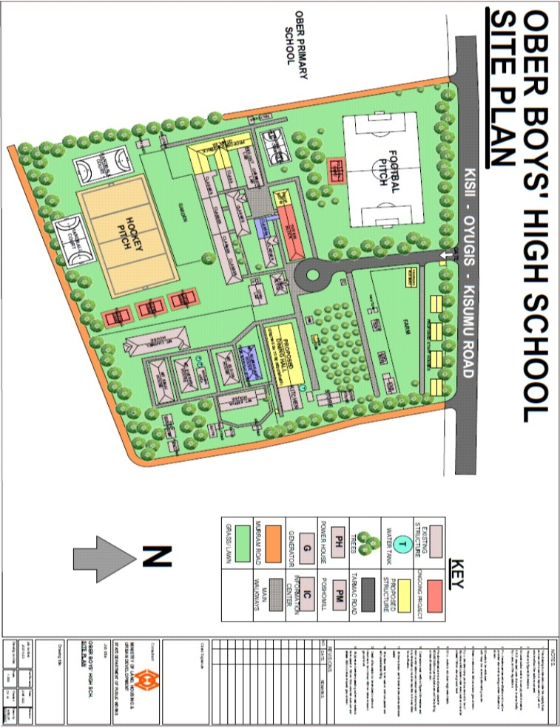

OBER BOYS HIGH SCHOOL STRATEGIC DEVELOPMENT PLAN (2023 – 2027) 44 | Page

Notes
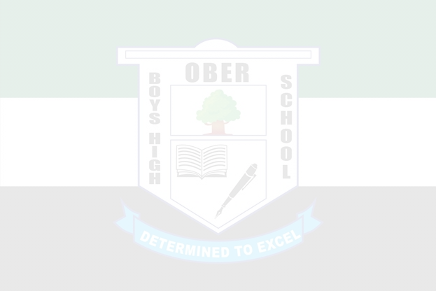

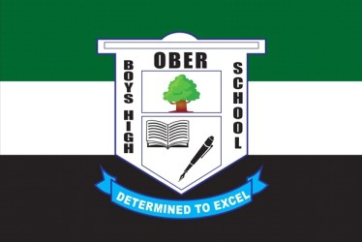
OBER BOYS HIGH SCHOOL STRATEGIC DEVELOPMENT PLAN (2023 – 2027) 45 | Page

Notes

OBER BOYS HIGH SCHOOL STRATEGIC DEVELOPMENT PLAN (2023 – 2027) 46 | Page

Notes

OBER BOYS HIGH SCHOOL STRATEGIC DEVELOPMENT PLAN (2023 – 2027) 47 | Page

